2017–2018–LGS–11.SORU B

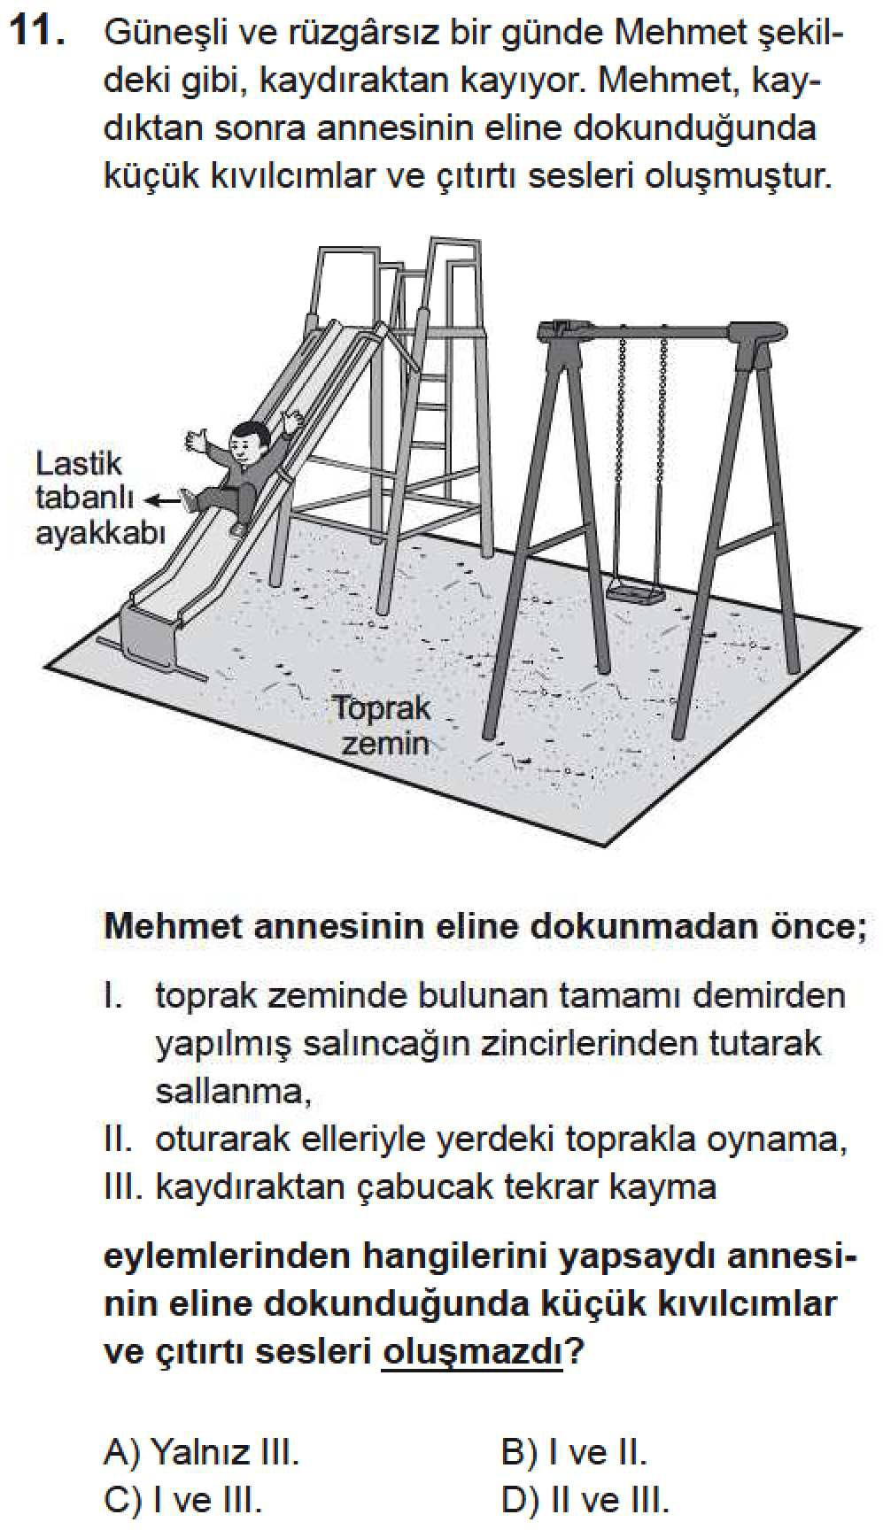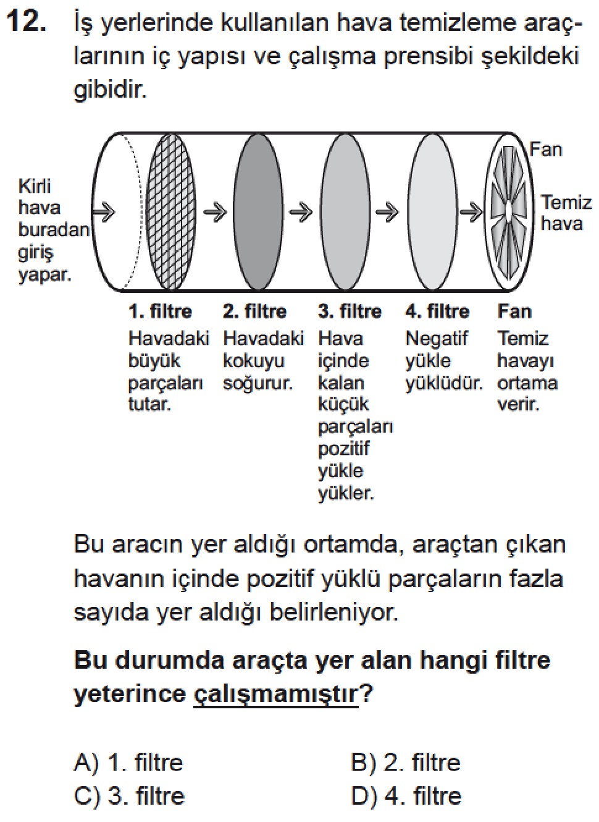

**2017–2018–LGS–12.SORU**

**D**

2017–2018–LGS–13.SORU D

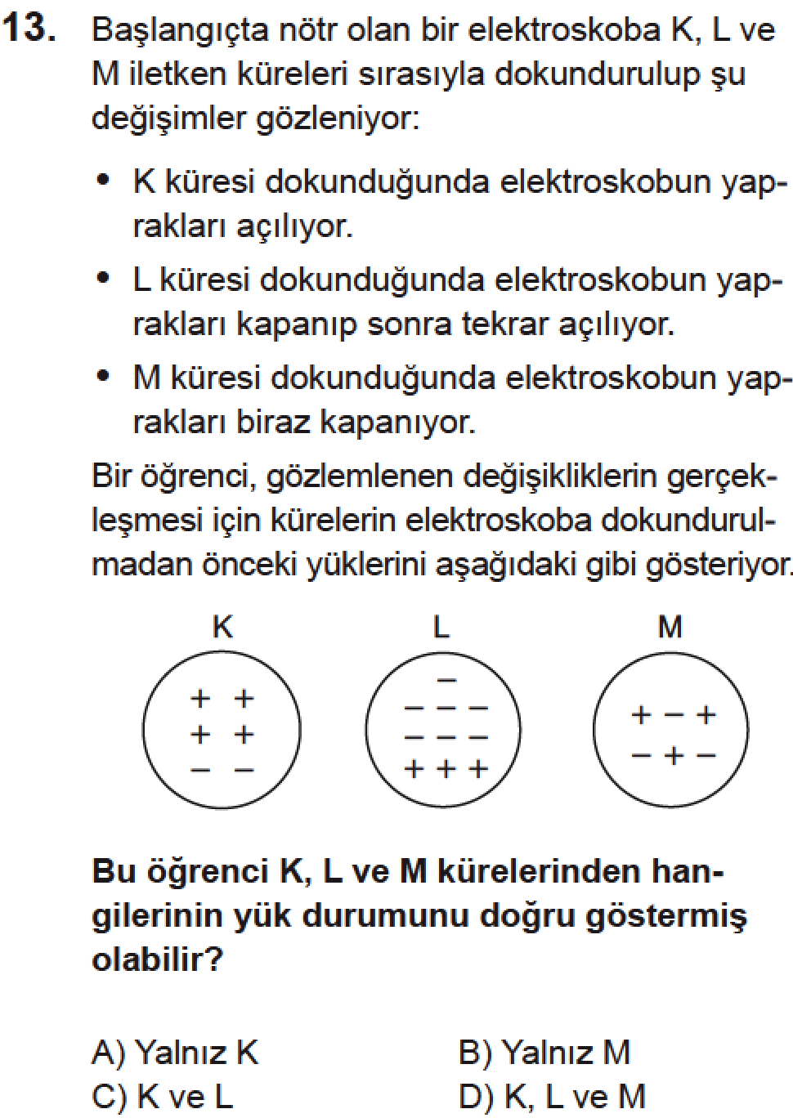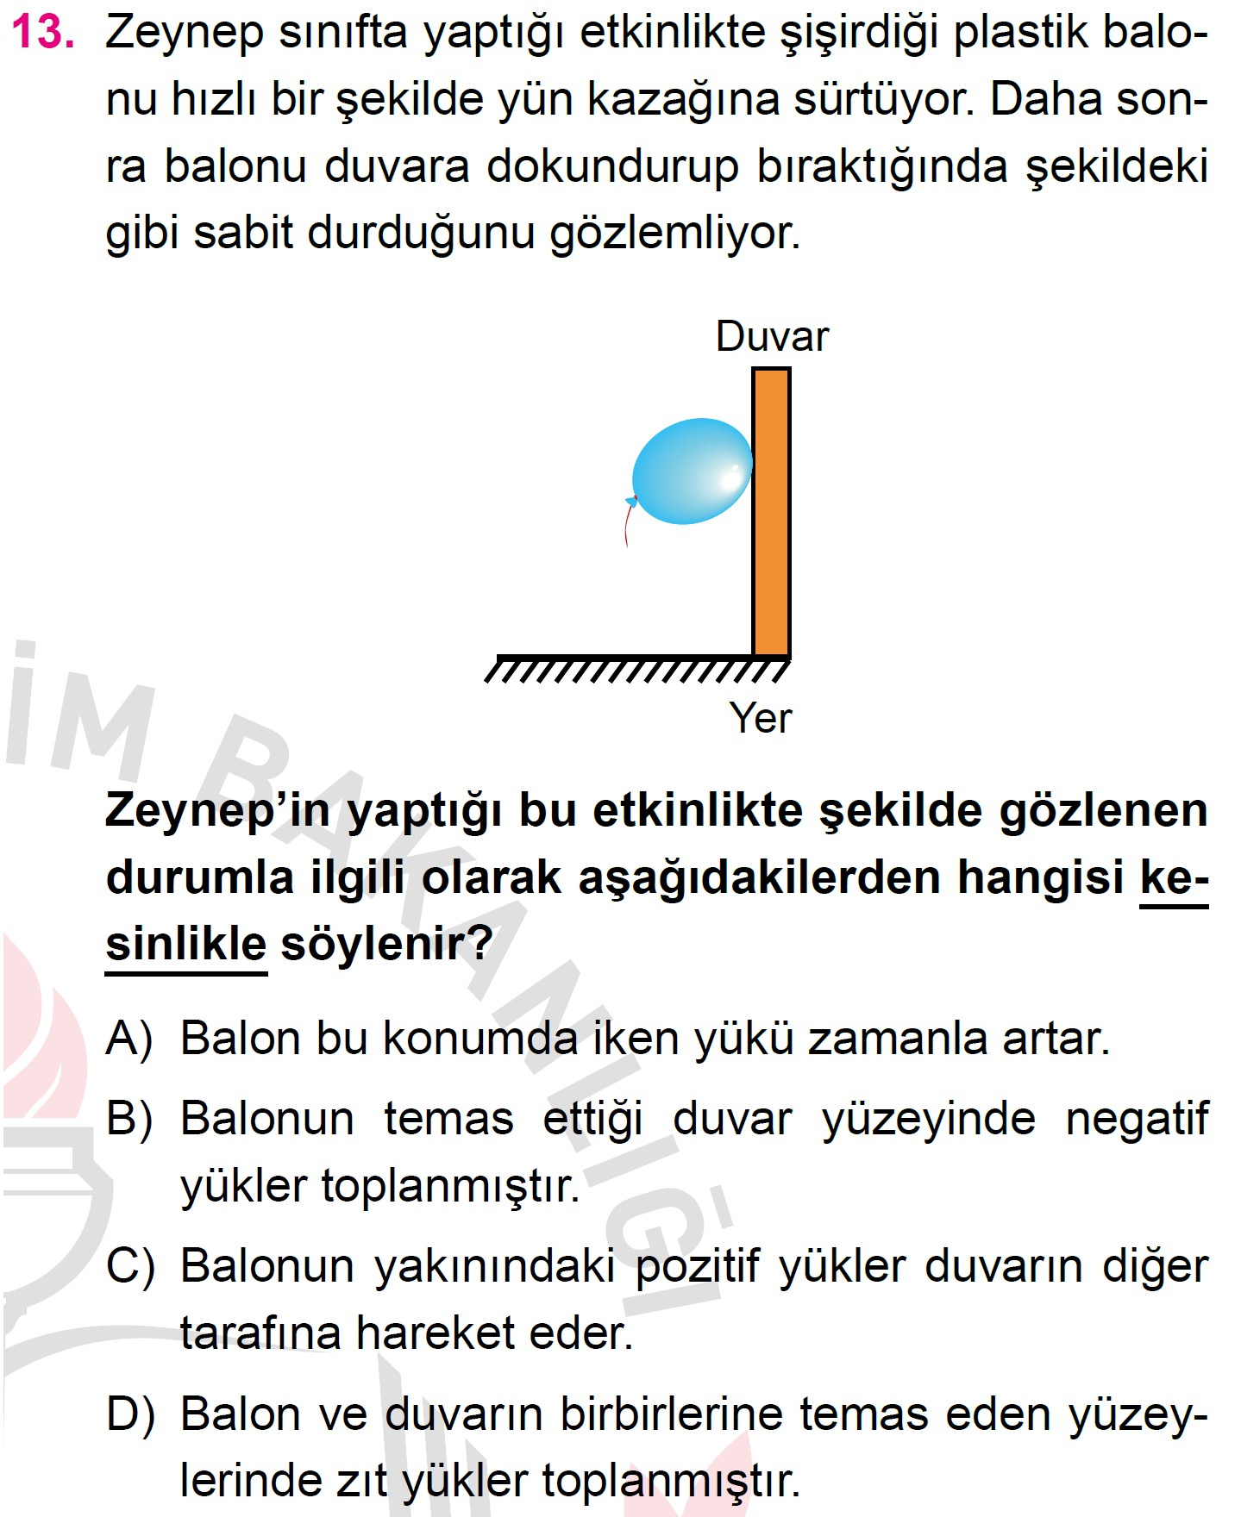

**2017–2018–LGS ÖRNEK SORULAR–13.SORU**

**D**

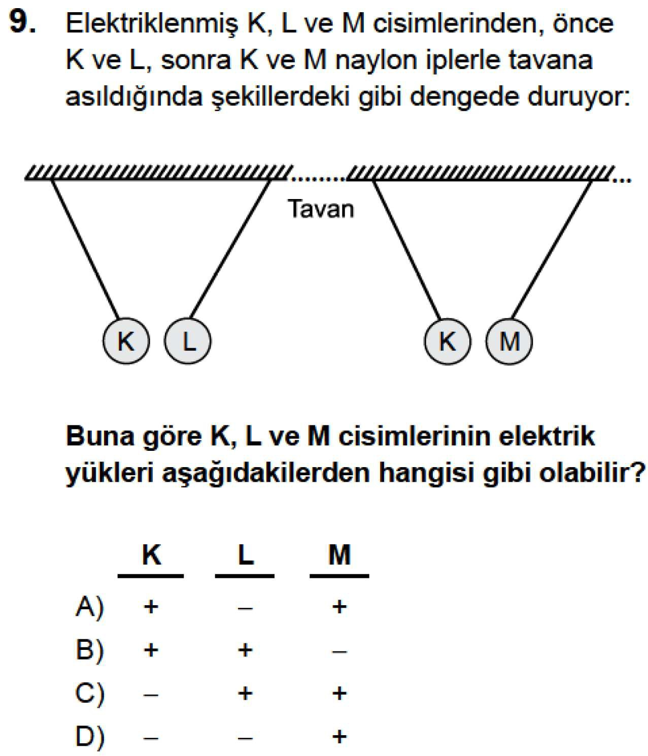

**2016–2017–TEOG–2 SINAVI–A KĐTAPÇIĞI–9.SORU**

**C**

2016–2017–TEOG–2 SINAVI–A KĐTAPÇIĞI–10.SORU D

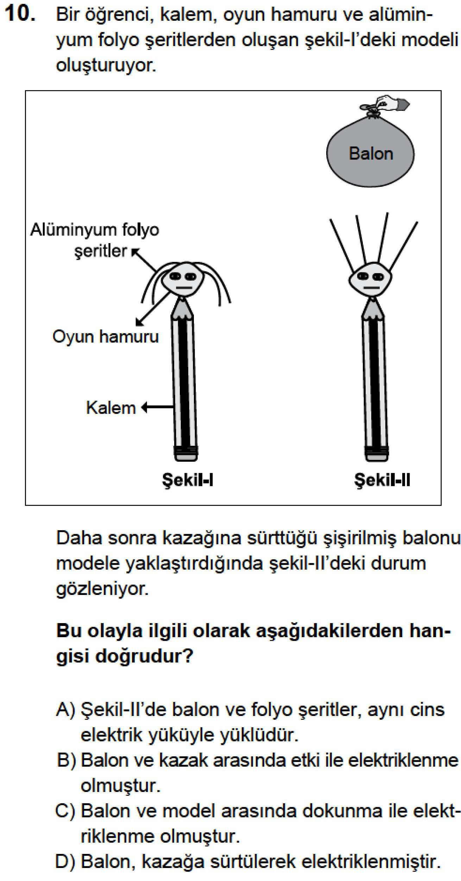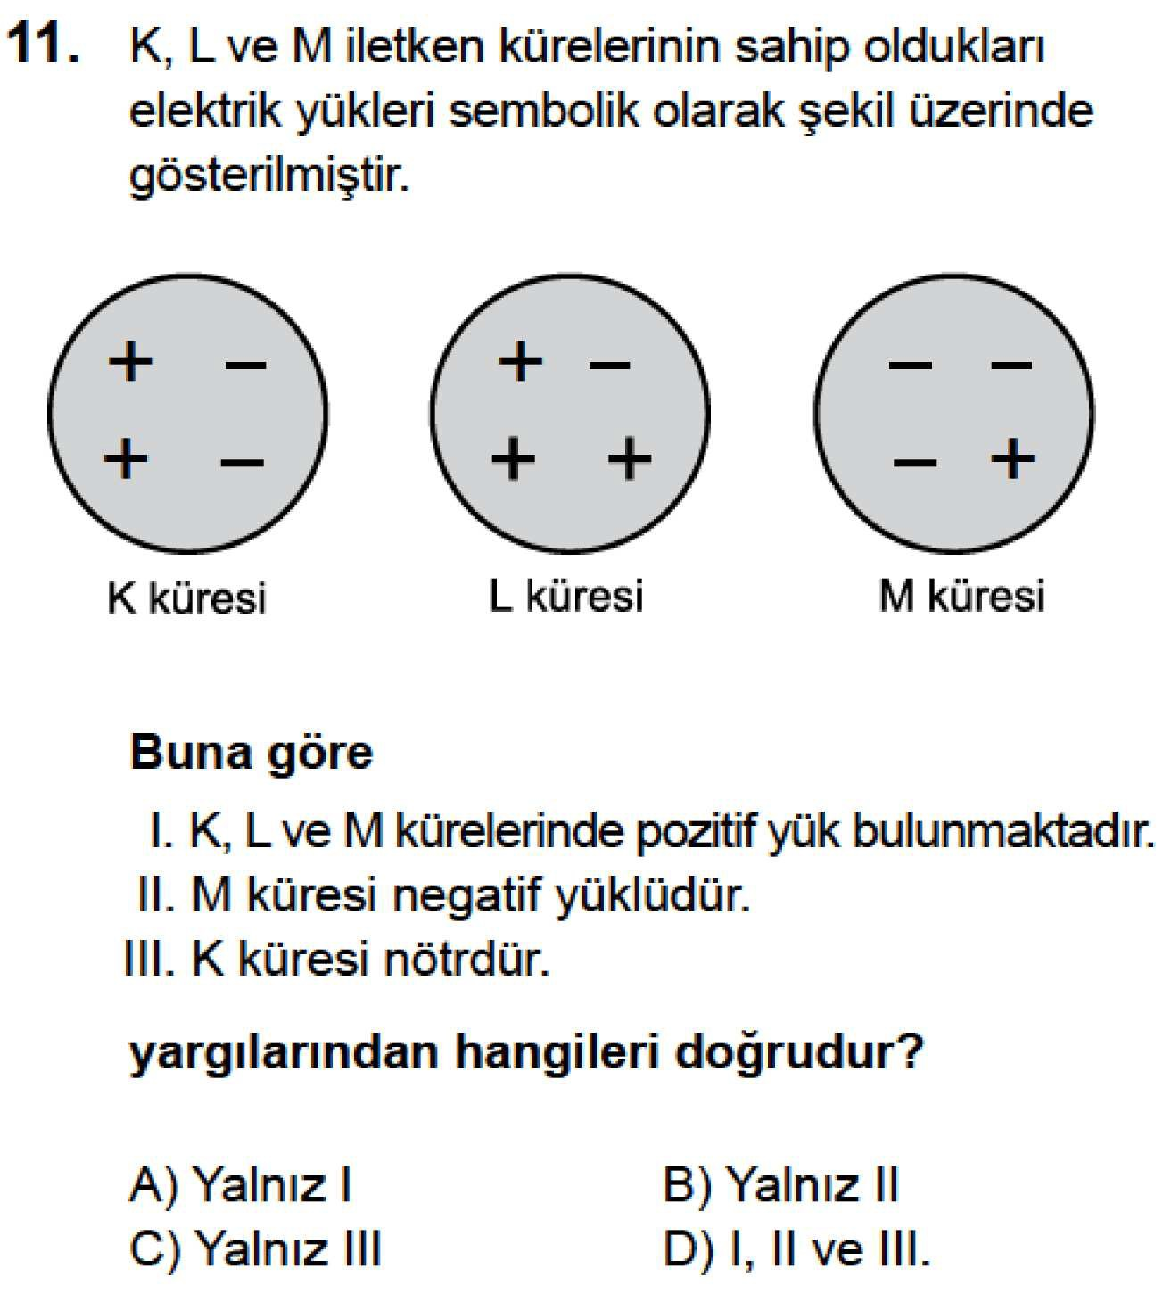

**2016–2017–TEOG–2 SINAVI–A KĐTAPÇIĞI–11.SORU**

**D**

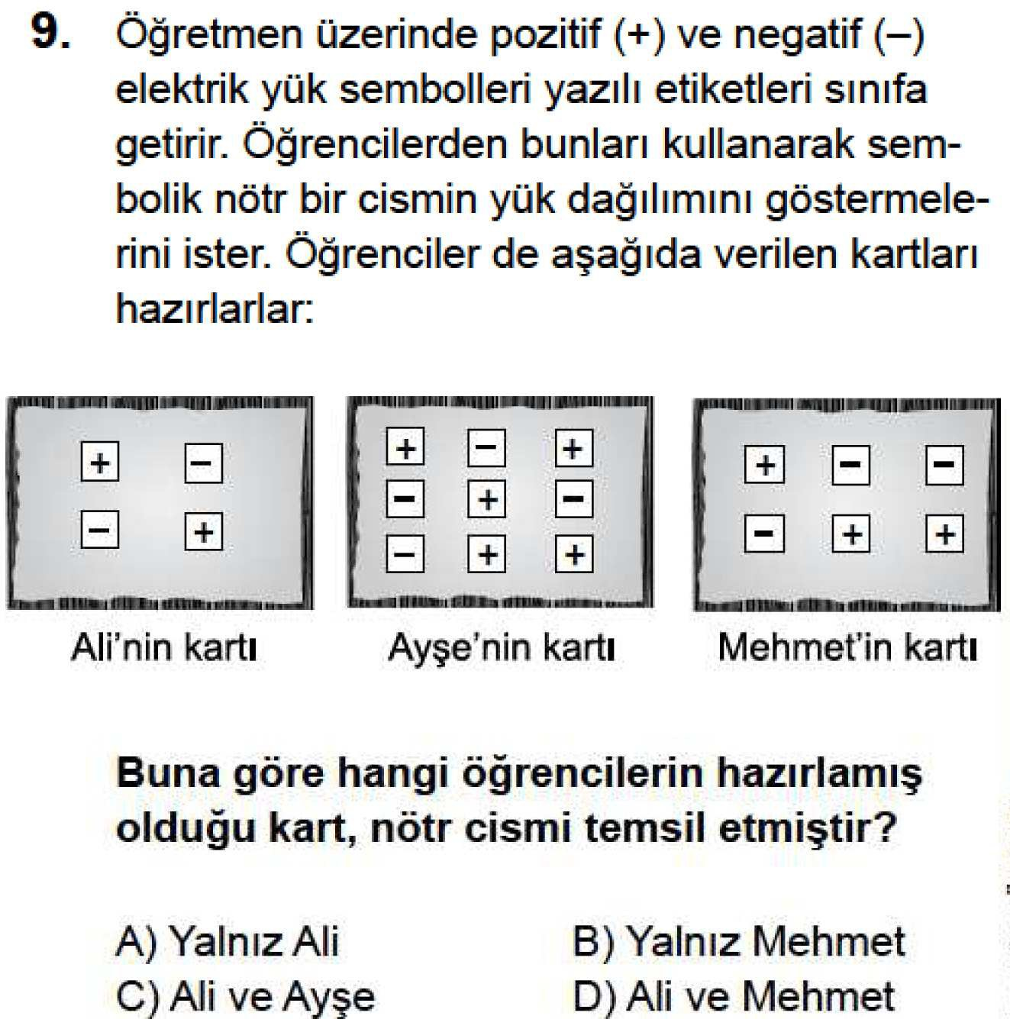

**2016–2017–TEOG–2 MAZERET SINAVI–A KĐTAPÇIĞI–9.SORU**

**D**

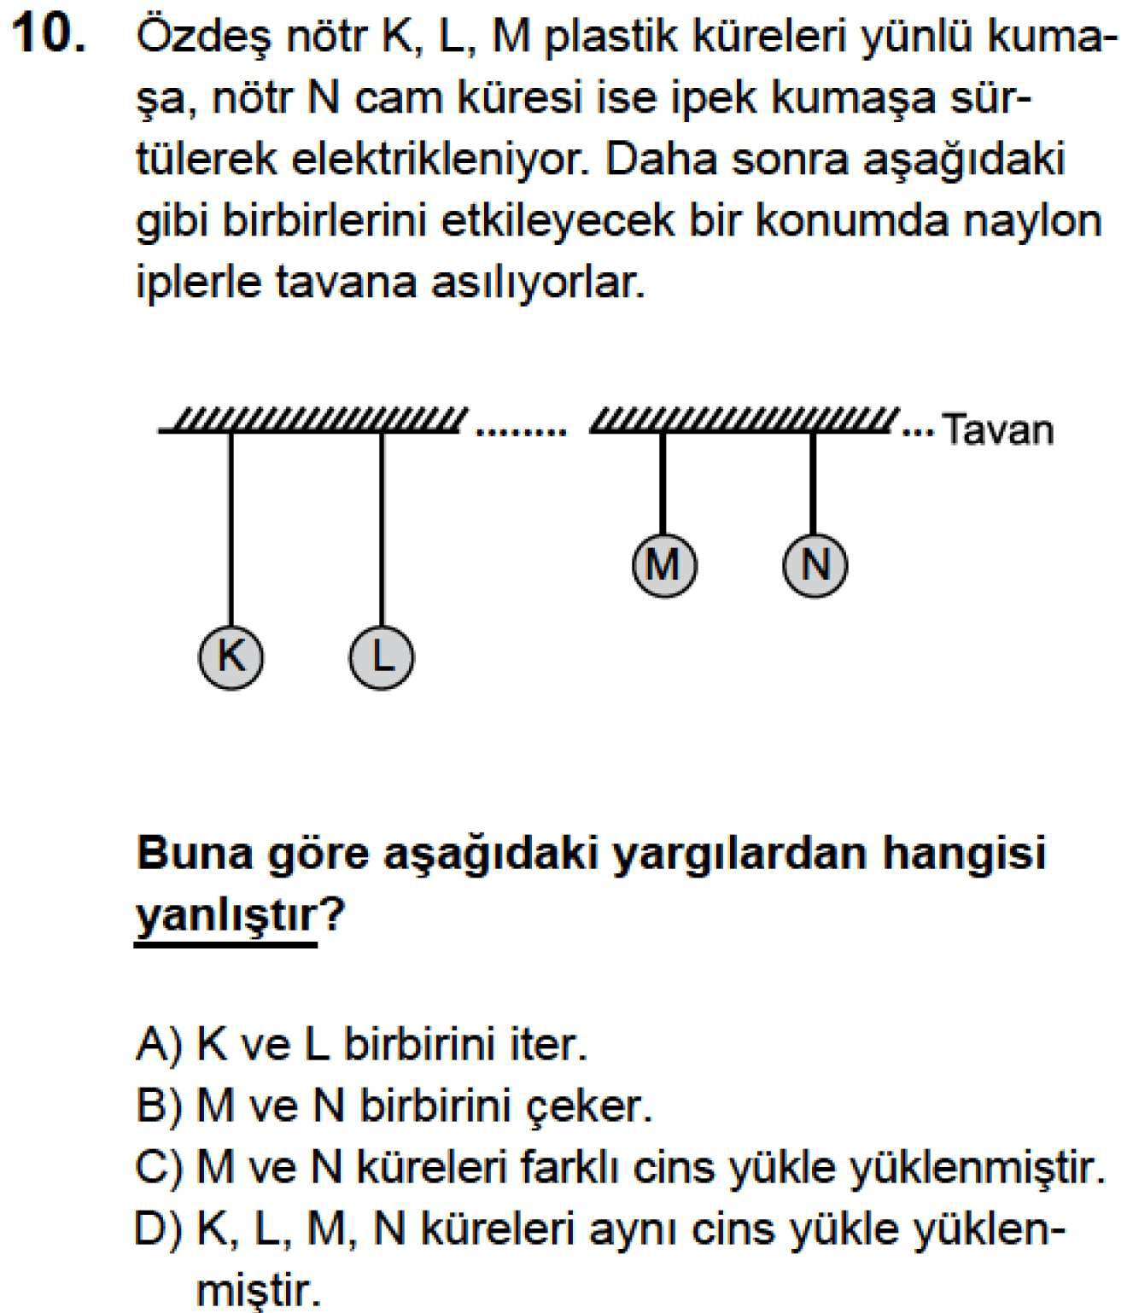

**2016–2017–TEOG–2 MAZERET SINAVI–A KĐTAPÇIĞI–10.SORU**

**D**

2016–2017–TEOG–2 MAZERET SINAVI–A KĐTAPÇIĞI–11.SORU C

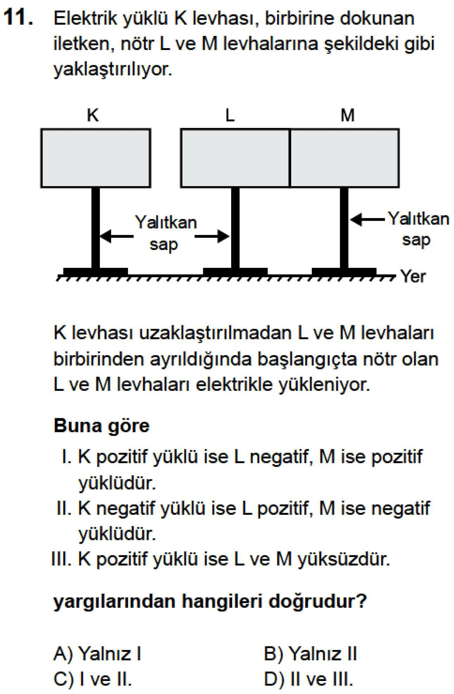

2014–2015 7.SINIF BURSLULUK SINAVI–A KĐTAPÇIĞI–4.SORU B

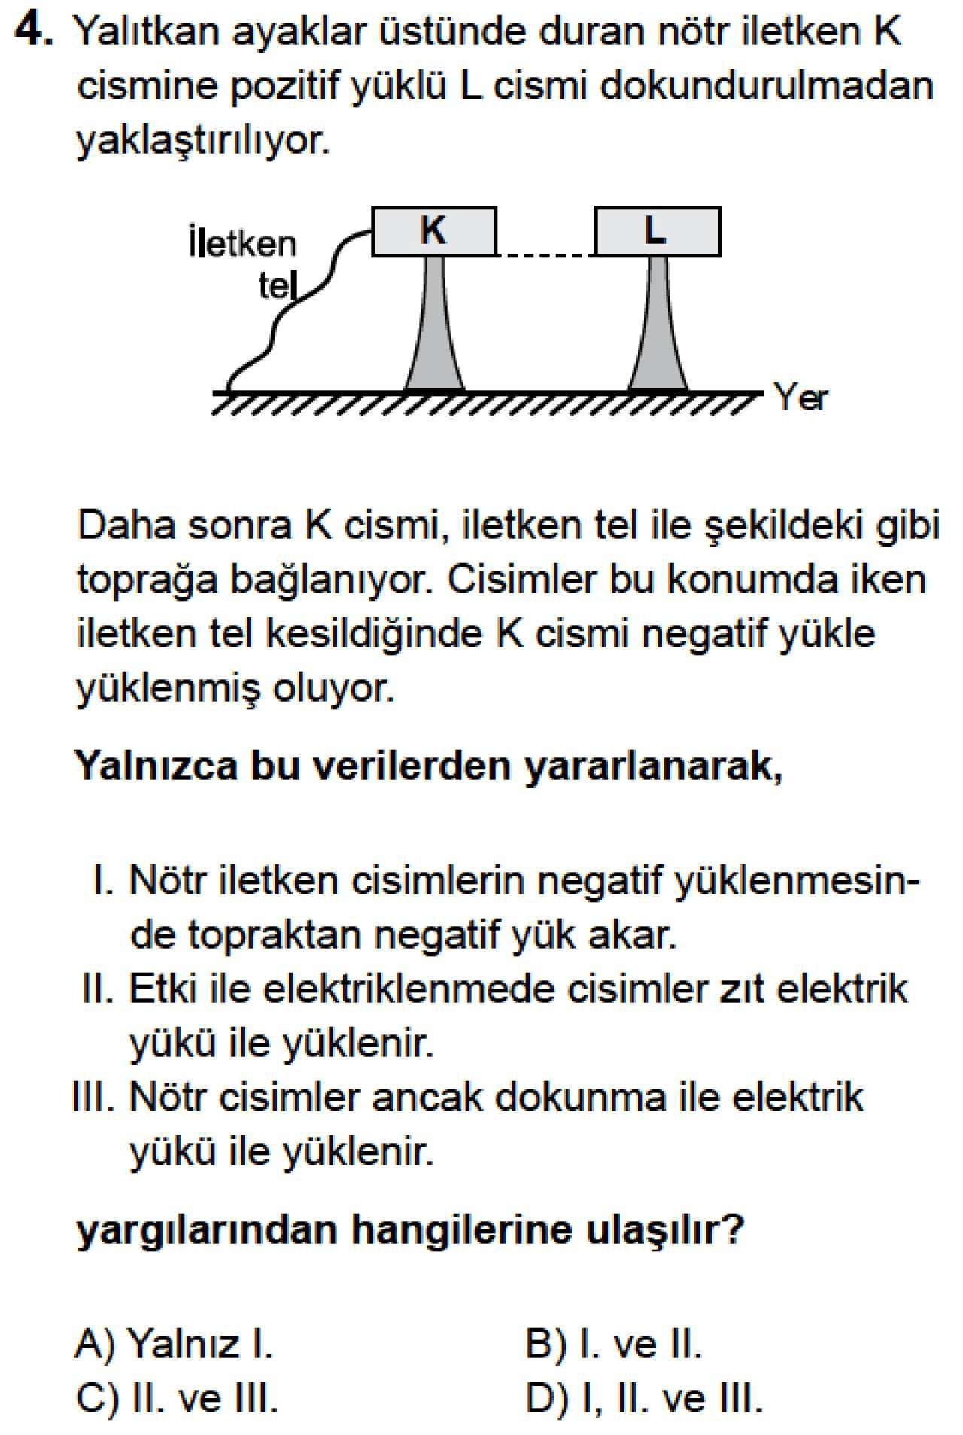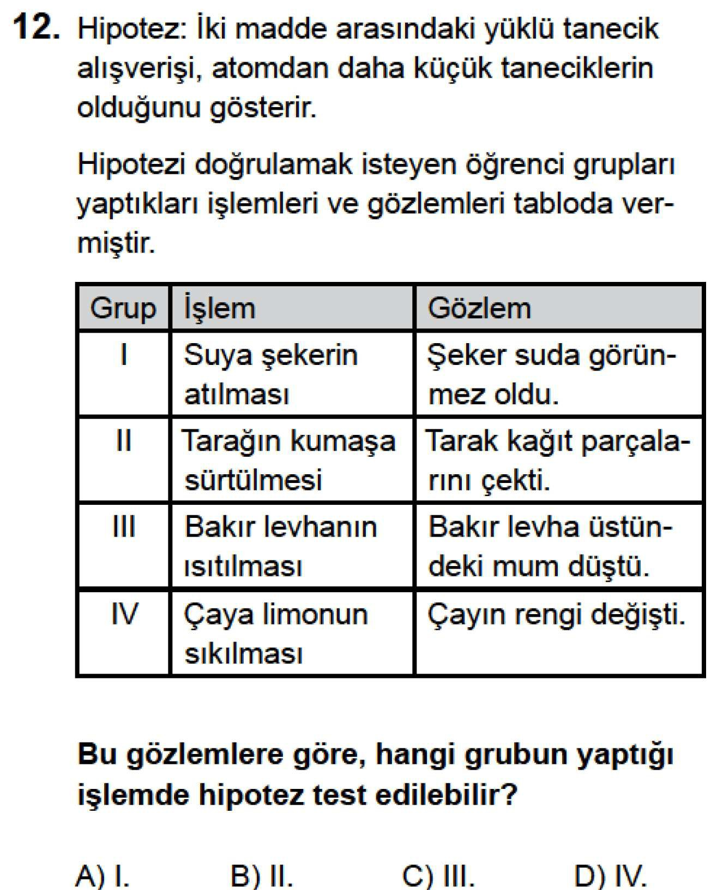

**2014–2015 7.SINIF BURSLULUK SINAVI–A KĐTAPÇIĞI–12.SORU**

**B**

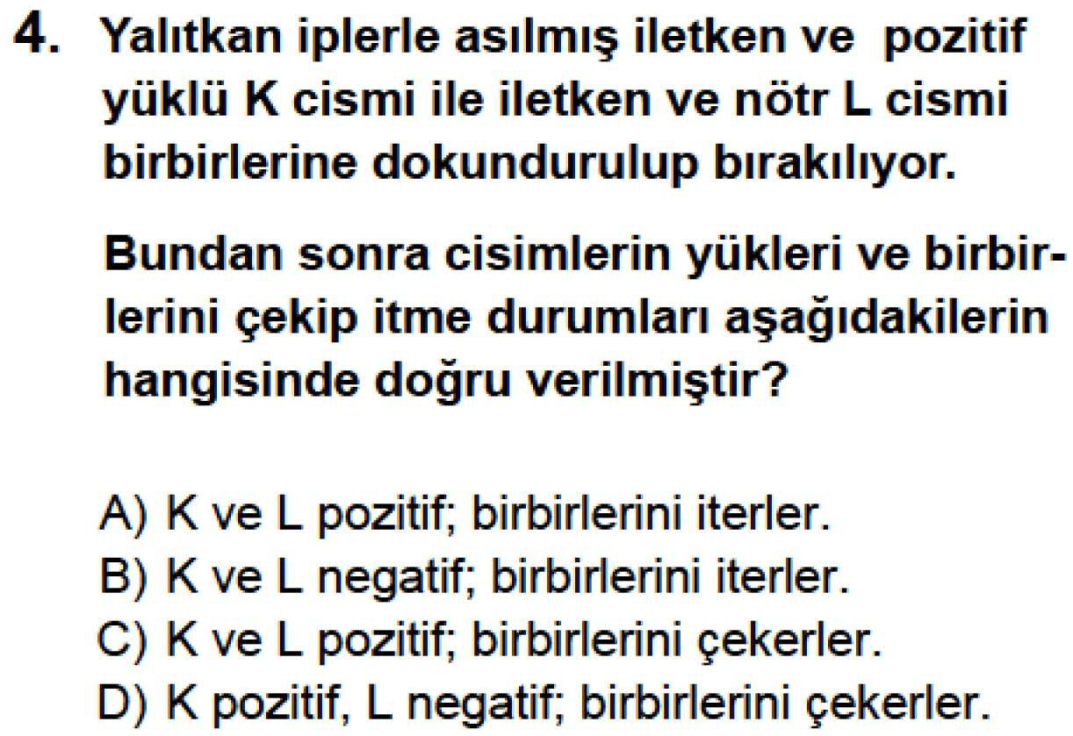

**2013–2014 7.SINIF BURSLULUK SINAVI–A KĐTAPÇIĞI–4.SORU**

**A**

2012–2013 7.SINIF BURSLULUK SINAVI–A KĐTAPÇIĞI–4.SORU B

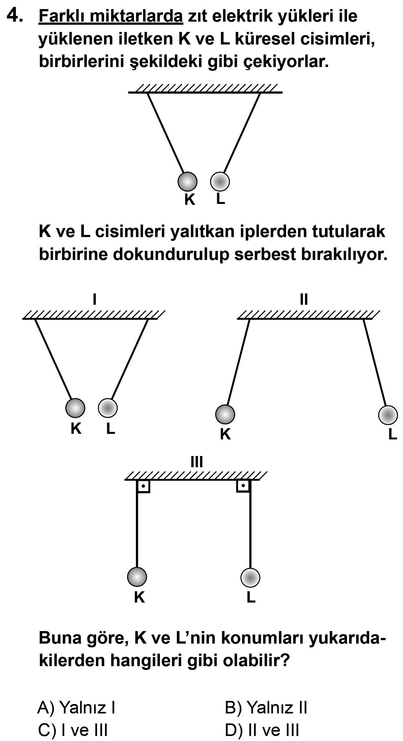

2012–2013 7.SINIF BURSLULUK SINAVI–A KĐTAPÇIĞI–13.SORU B

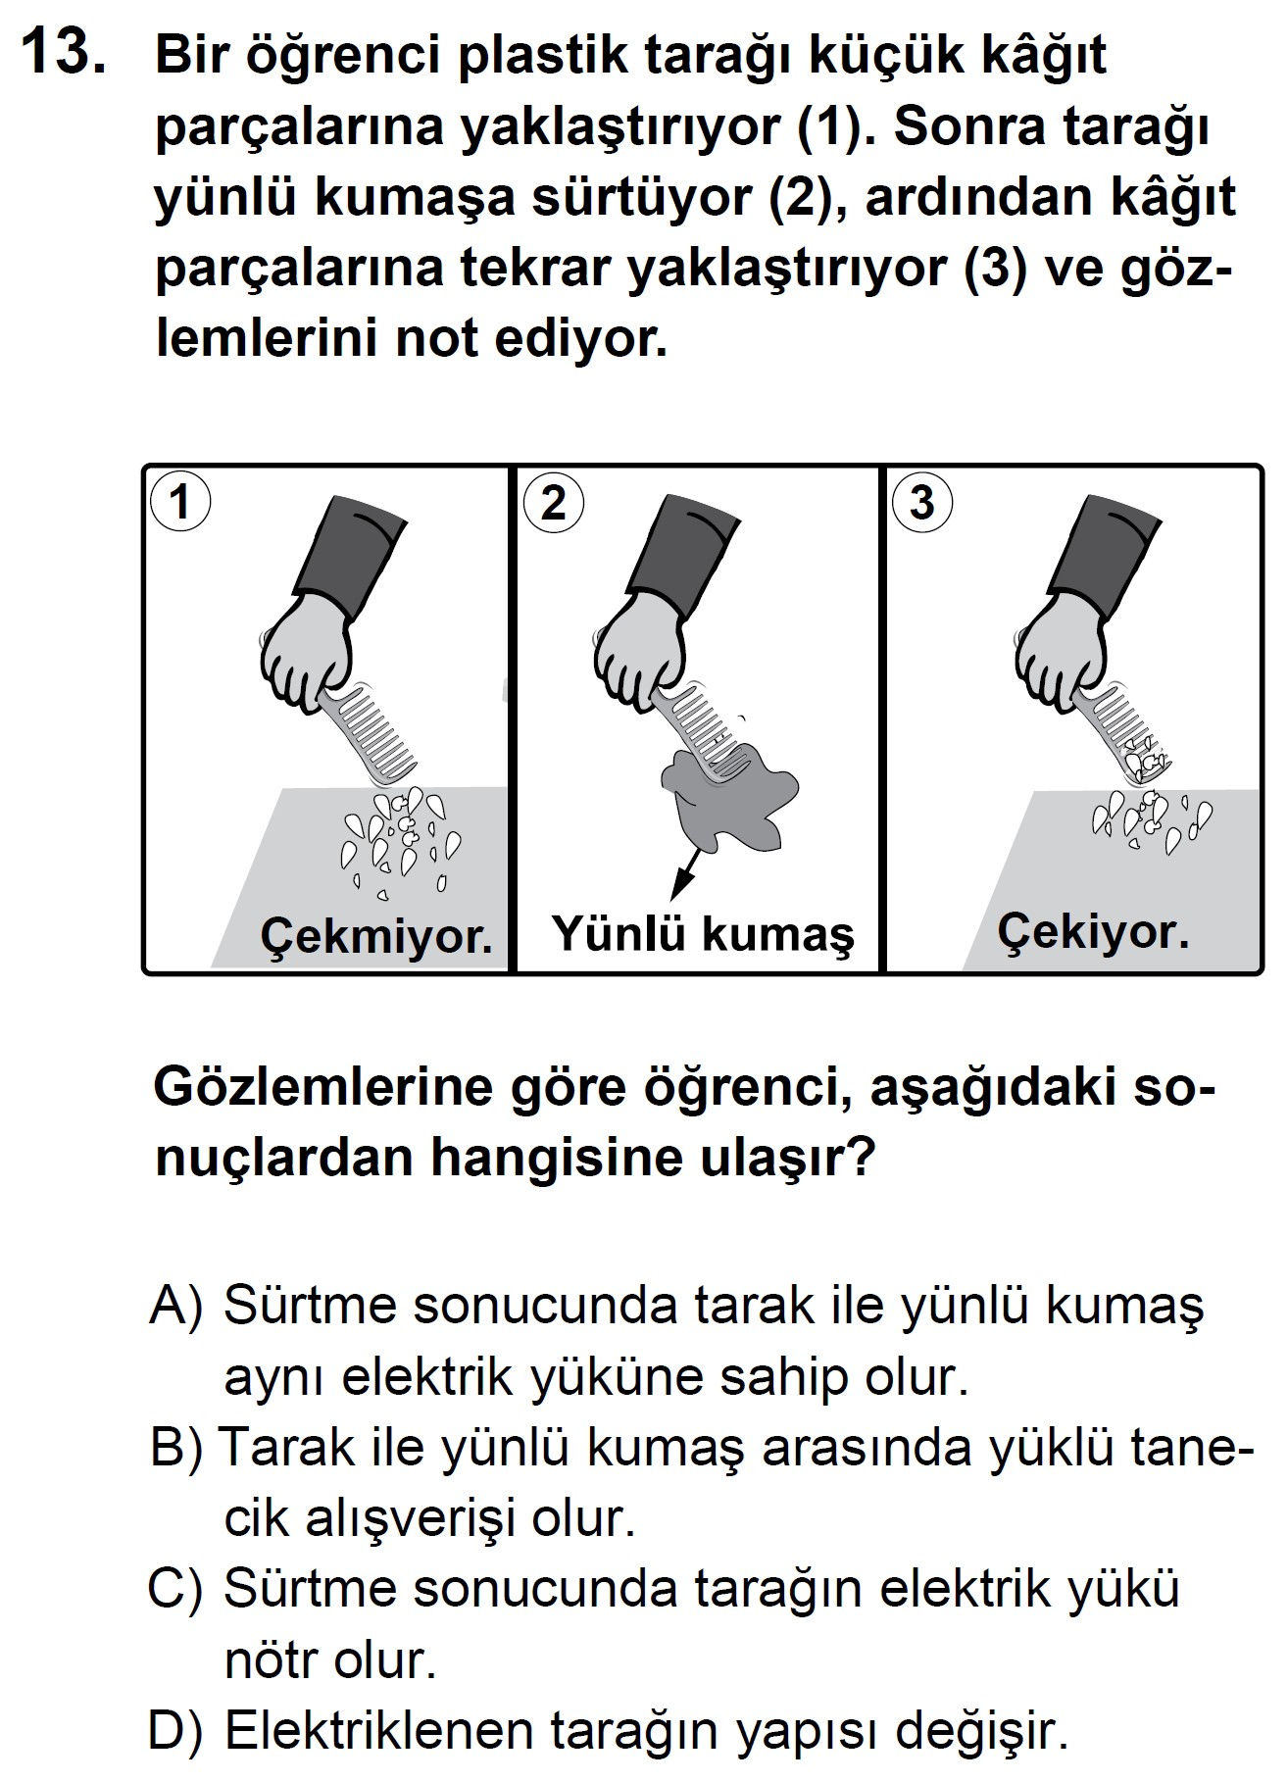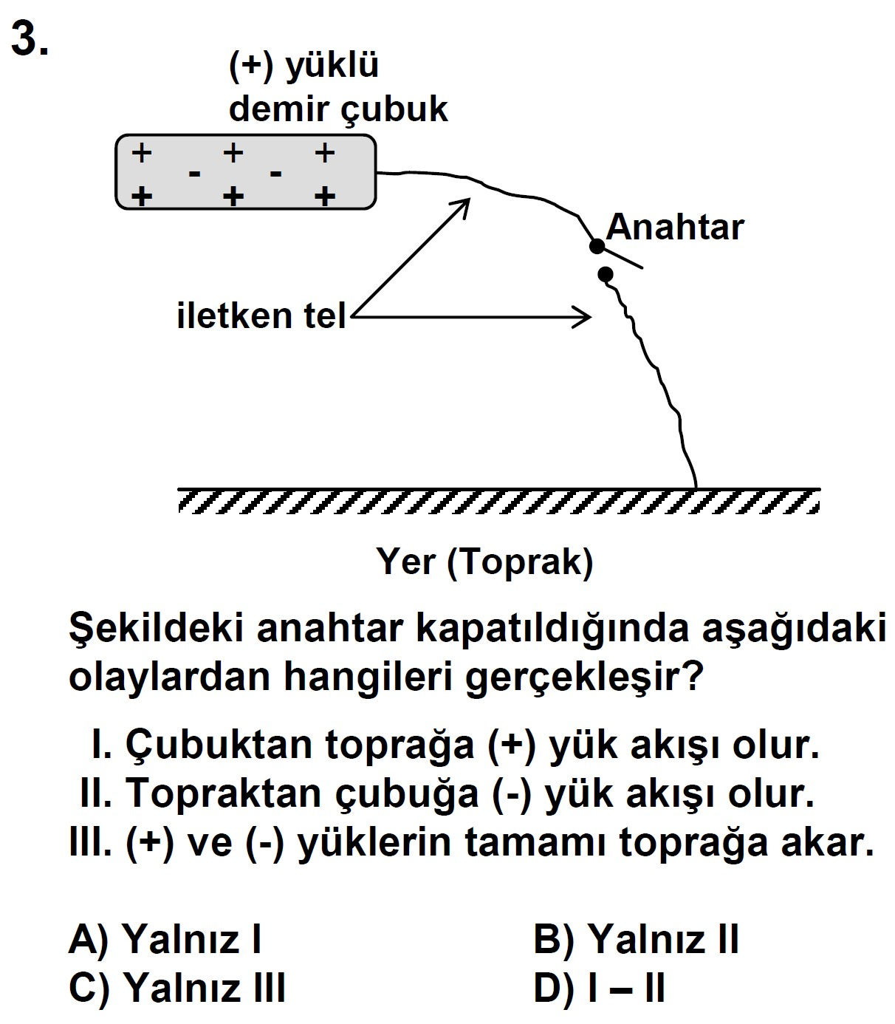

**2006–2007 7.SINIF SBS–A KĐTAPÇIĞI–3.SORU**

**B**

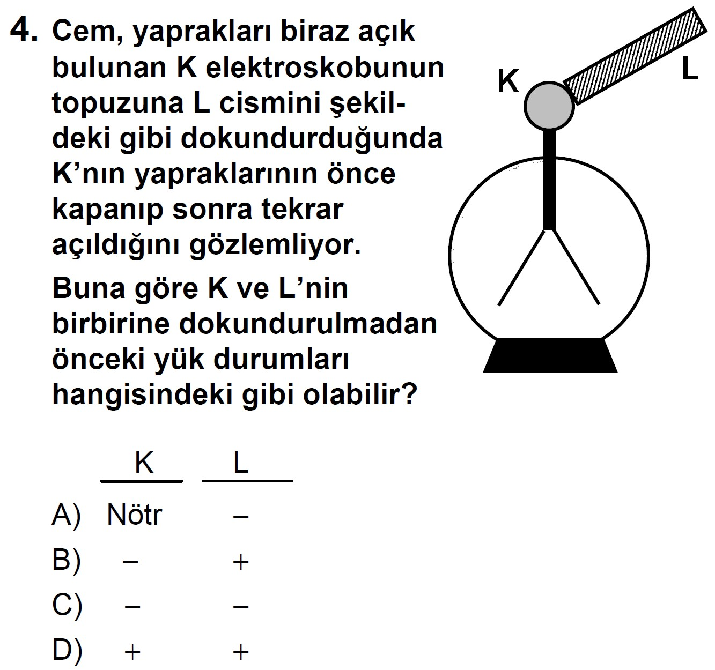

**2007–2008 7.SINIF SBS–A KĐTAPÇIĞI–4.SORU**

**B**

2009–2010 7.SINIF SBS–A KĐTAPÇIĞI–6.SORU C

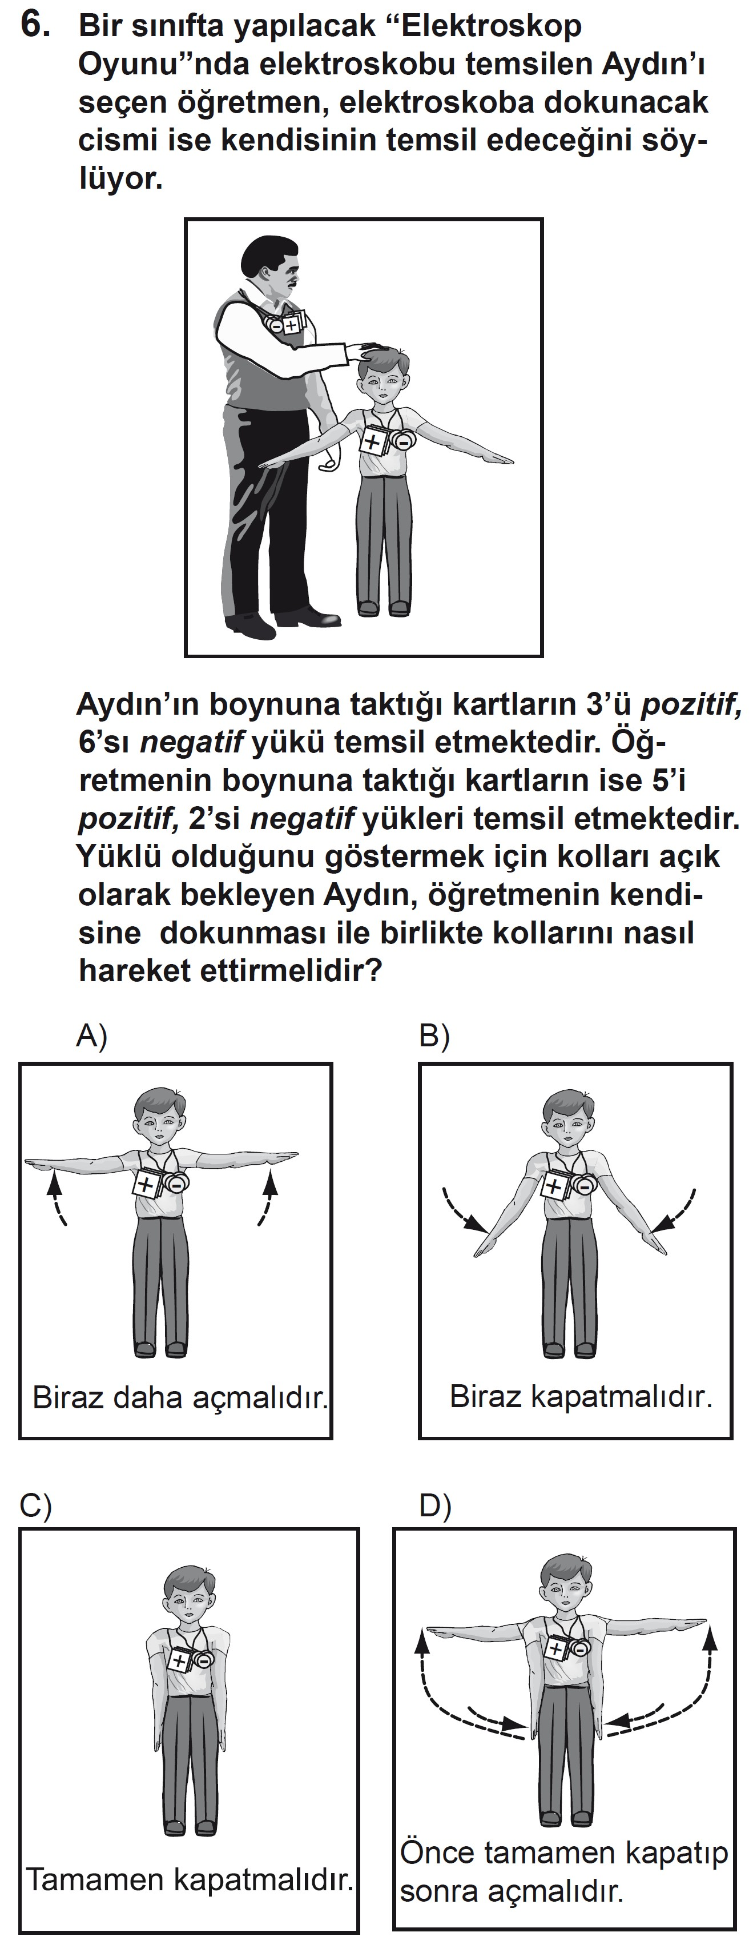

2010–2011 7.SINIF SBS–A KĐTAPÇIĞI–2.SORU D

