### 7. SINIFLAR ÜNİTE ÜNİTE “ÇIKMIŞ SORULAR” 6. ÜNİTE: “CANLILARDA ÜREME BÜYÜME ve GELİŞME”

### 1. (2018 5. SINIF BURSLULUK)

### 

**2.** (2018 5. SINIF BURSLULUK)**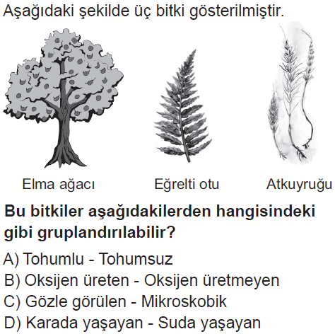3.**  (2018 6. SINIF BURSLULUK)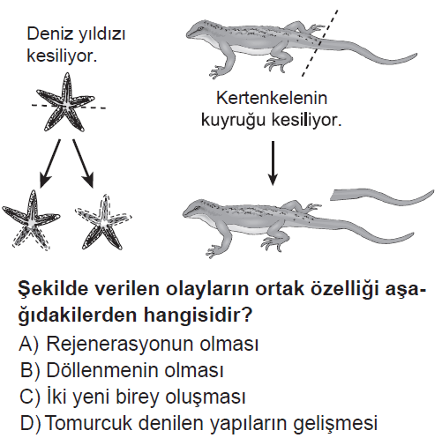

**4.** (2018 6. SINIF BURSLULUK)

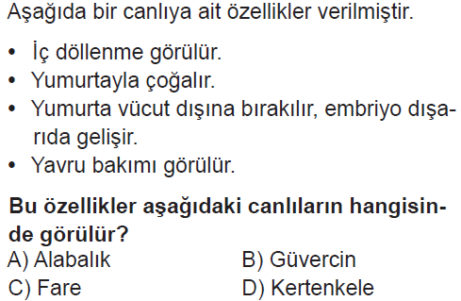

**5.** (2018 6. SINIF BURSLULUK)

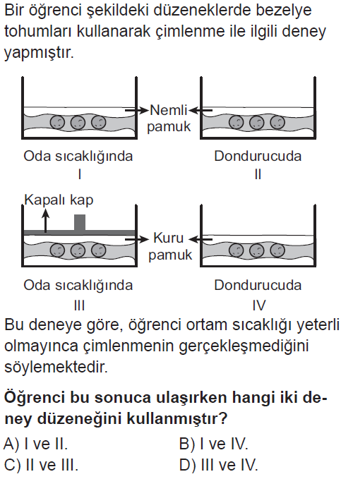

**6.** (2017 5. SINIF BURSLULUK)

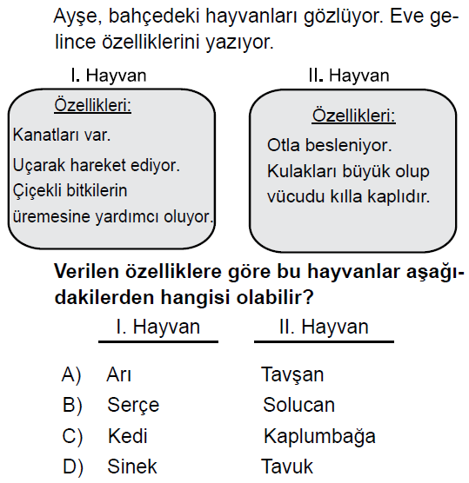

**7.** (2017 5. SINIF BURSLULUK)

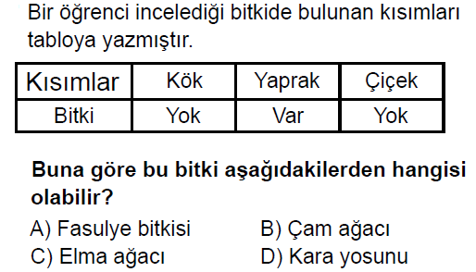

**8.** (2017 6. SINIF BURSLULUK)

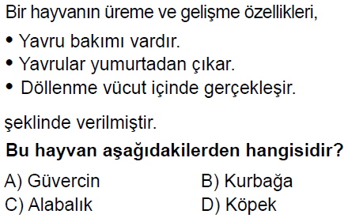

**9.**

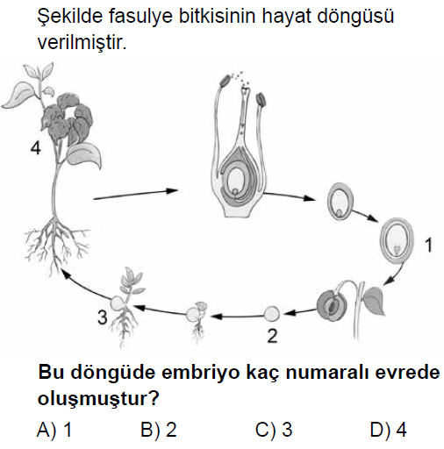

**10.** (2017 6. SINIF BURSLULUK)

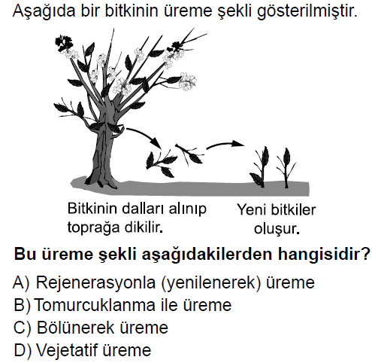

**11.** (2017 7. SINIF BURSLULUK)

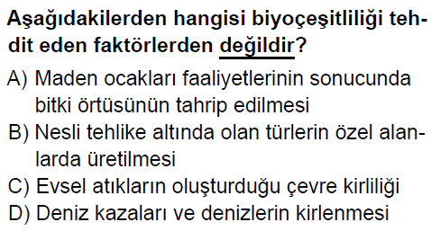

**12.** (2017 HAZIRLIK SINIFI BURSLULUK)

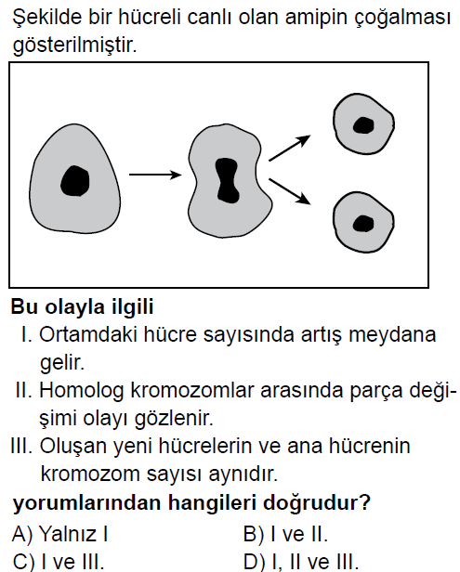

**13.** (2016 5. SINIF BURSLULUK)

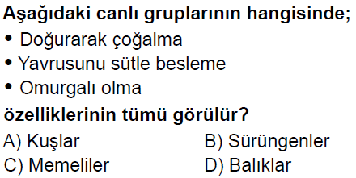

**14.** (2016 6. SINIF BURSLULUK)

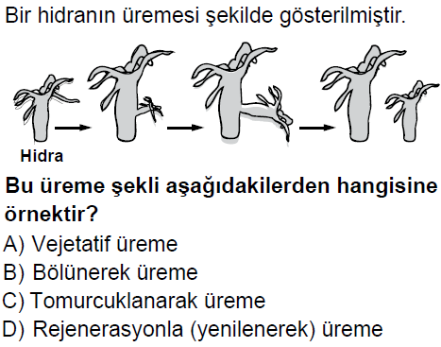

**15.** (2016 6. SINIF BURSLULUK)

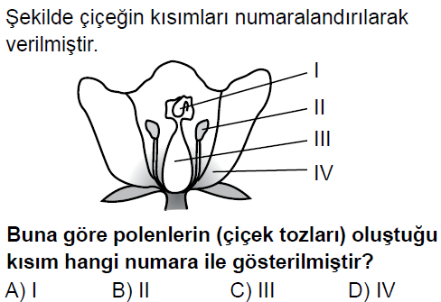

**16.** (2016 6. SINIF BURSLULUK)

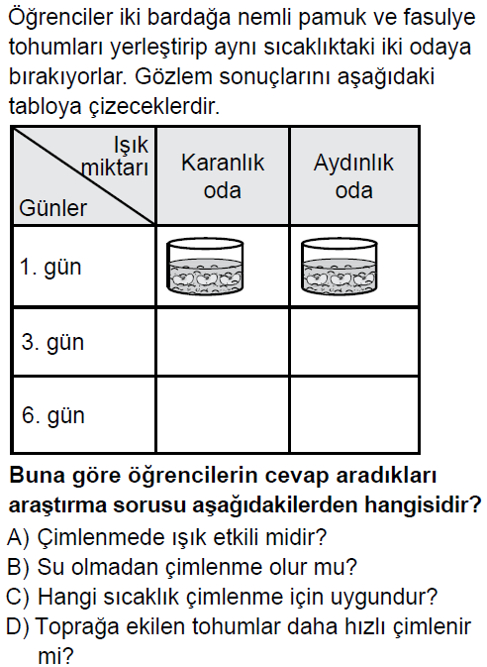

**17.** (2016 6. SINIF BURSLULUK)

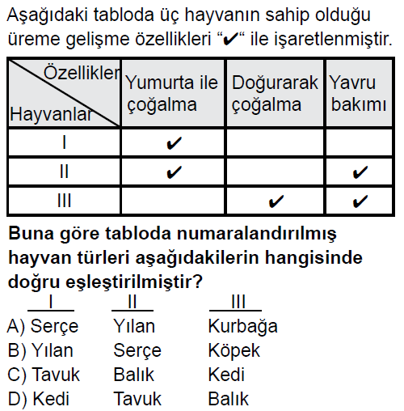

**18.** (2016 7. SINIF BURSLULUK)

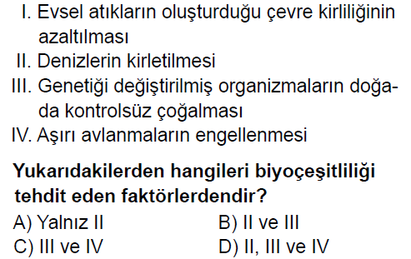

**19.** (2015 5. SINIF BURSLULUK)

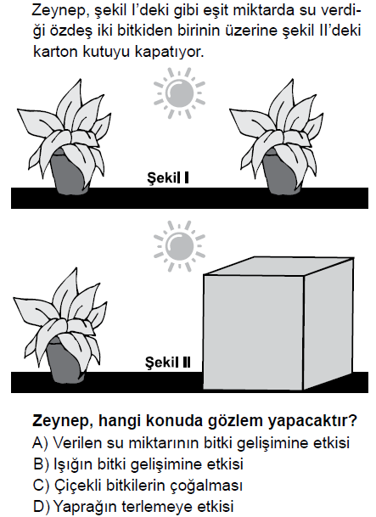

**20.** (2015 5. SINIF BURSLULUK)

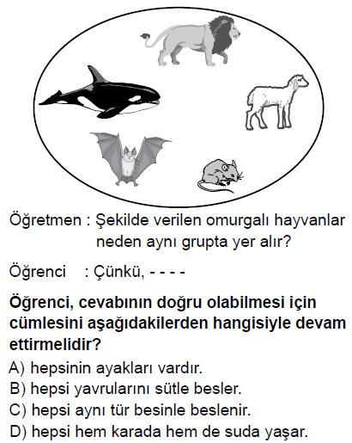

**21.** (2015 6. SINIF BURSLULUK)

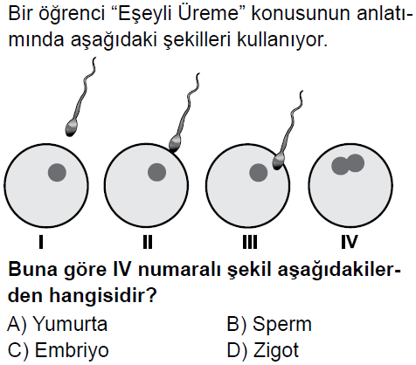

**22.** (2015 6. SINIF BURSLULUK)

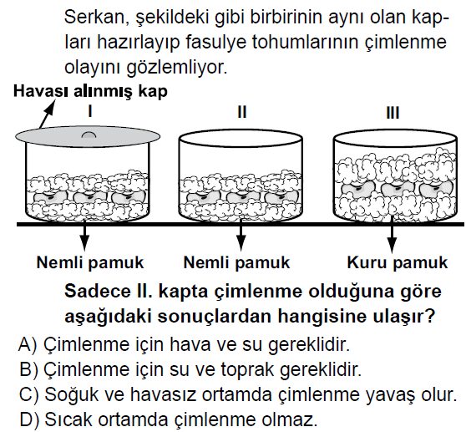

**23.** (2015 6. SINIF BURSLULUK)

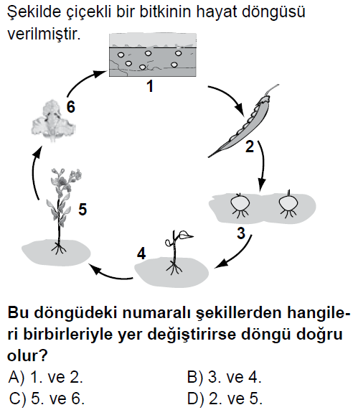

**24.** (2015 6. SINIF BURSLULUK)

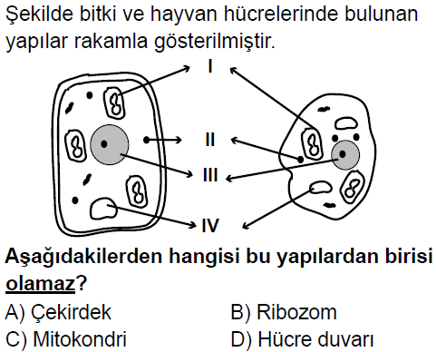

**25.** (2014 5. SINIF BURSLULUK)

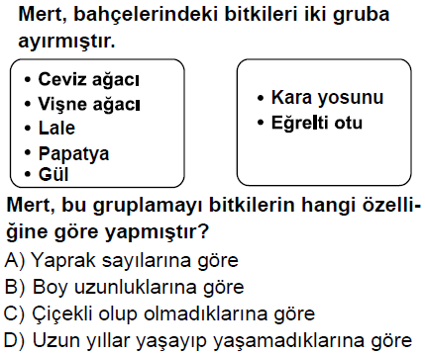

**26.** (2014 5. SINIF BURSLULUK)

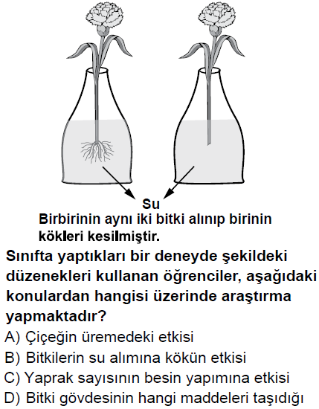

**27.** (2014 5. SINIF BURSLULUK)

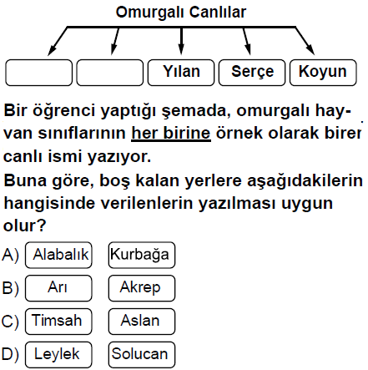

**28.** (2014 6.SINIF BURSLULUK)

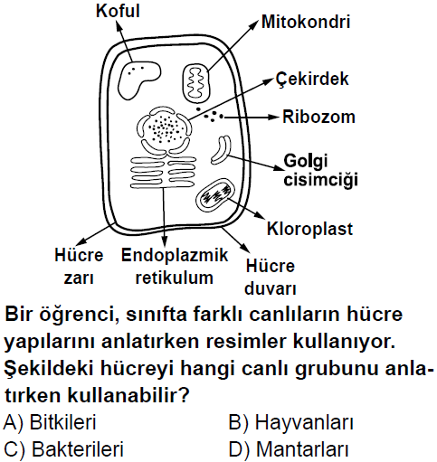

**29.** (2014 6. SINIF BURSLULUK)

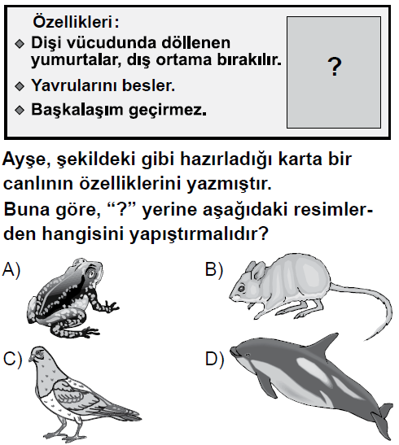

**30.** (2014 6. SINIF BURSLULUK)

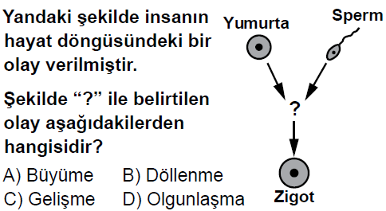

**31.** (2014 6. SINIF BURSLULUK)

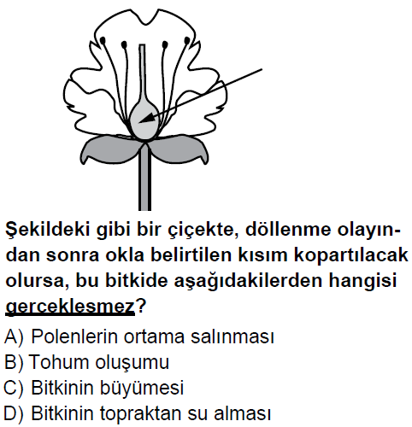

**32.** (2014 6. SINIF BURSLULUK)

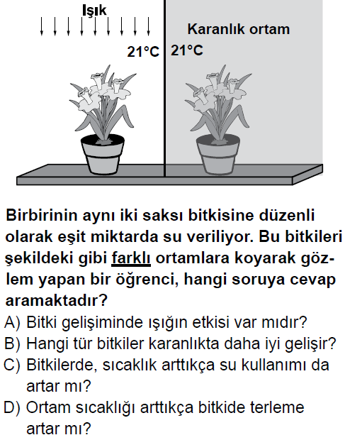

**33.** (2013 5. SINIF BURSLULUK)

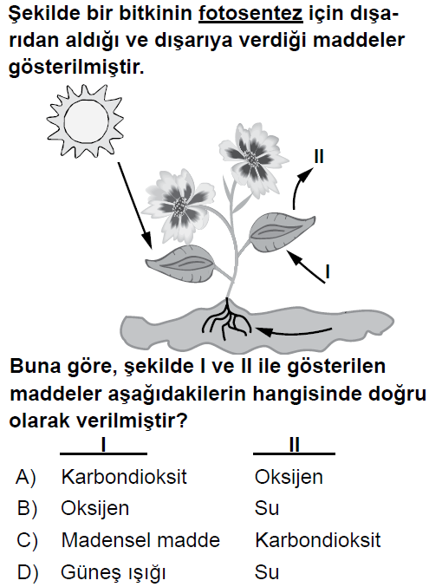

**34.** (2013 6. SINIF BURSLULUK)

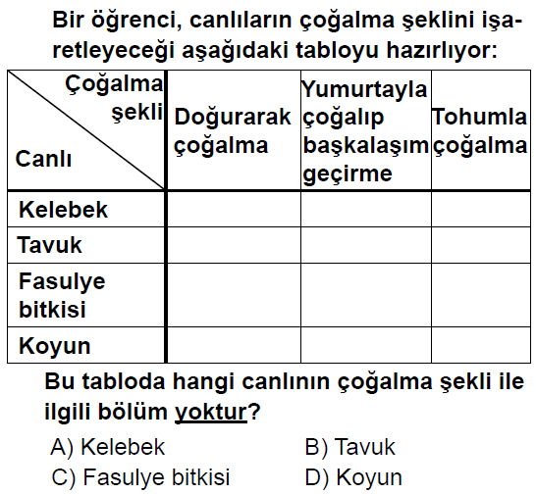

**35.** (2013 7. SINIF BURSLULUK)

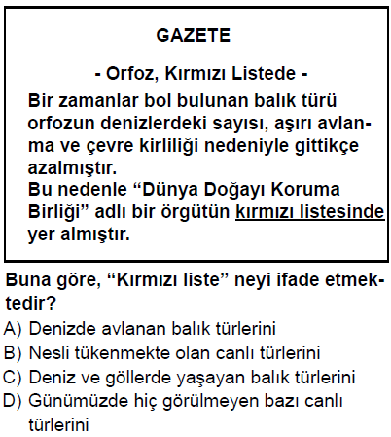

**36.** (2013 6. SINIF BURSLULUK)

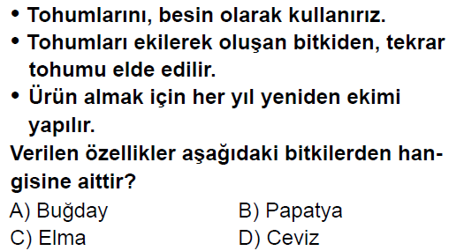

**37.** (2013 7. SINIF BURSLULUK)

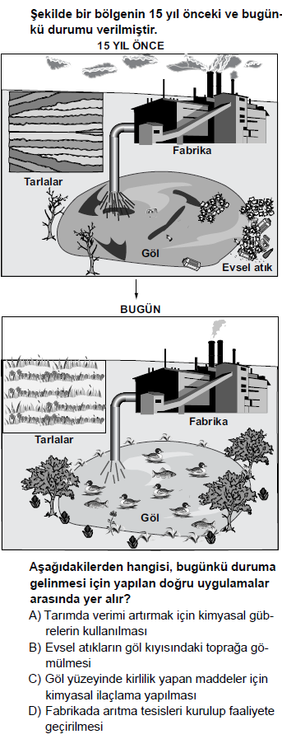

**38.** (2012 5. SINIF BURSLULUK)

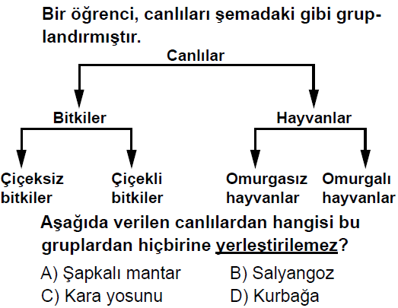

**39.** (2012 5. SINIF BURSLULUK)

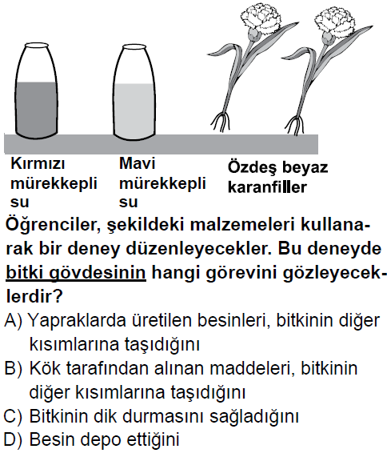

**40.** (2012 5. SINIF BURSLULUK)

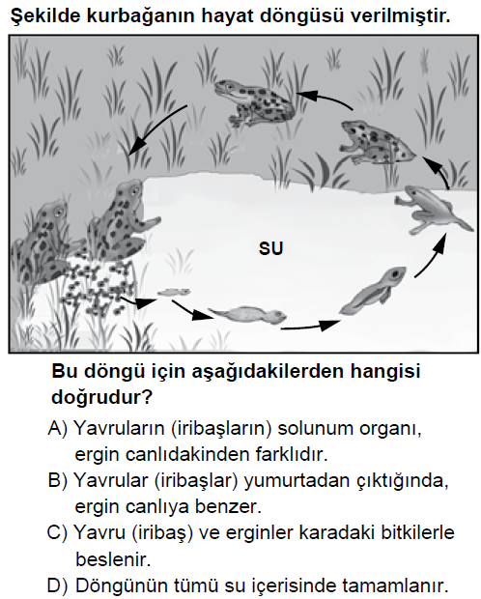

**41.** (2012 6. SINIF BURSLULUK)

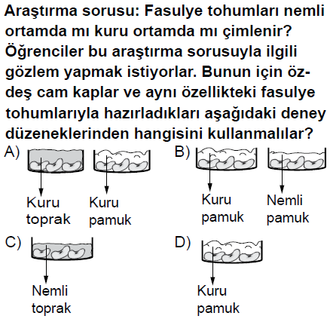

**42.** (2012 6. SINIF BURSLULUK)

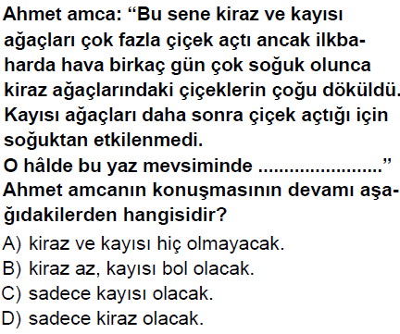

**43.** (2011 5. SINIF BURSLULUK)

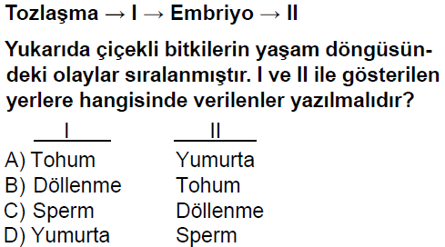

**44.** (2011 5. SINIF BURSLULUK)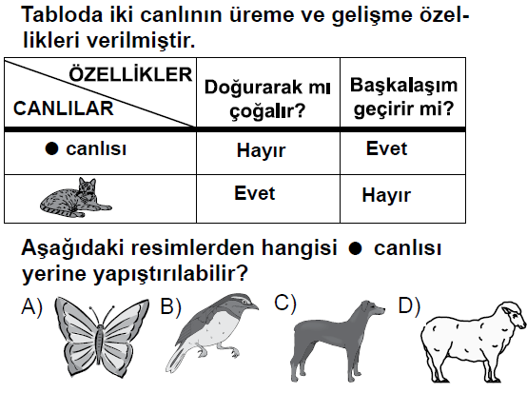

**45.** (2011 6. SINIF BURSLULUK)

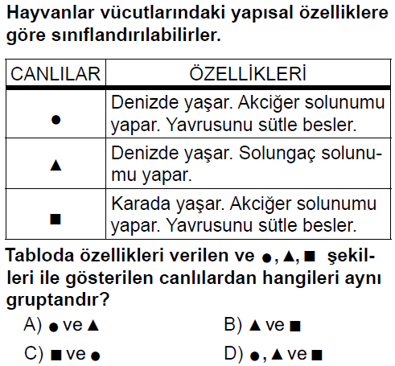

**46.** (2011 6. SINIF BURSLULUK)

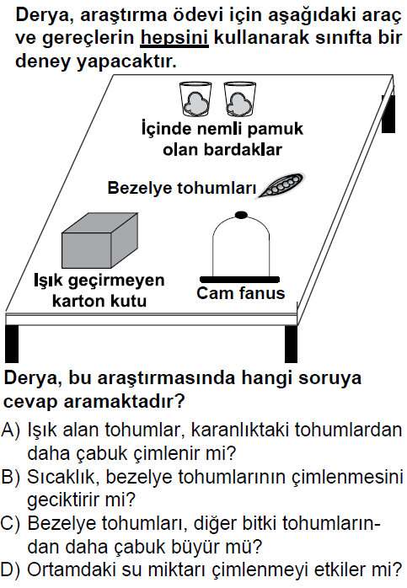

**47.** (2010 5. SINIF BURSLULUK)

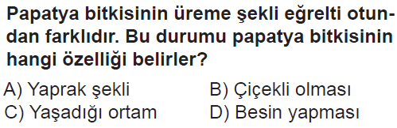

**48.** (2010 5. SINIF BURSLULUK)

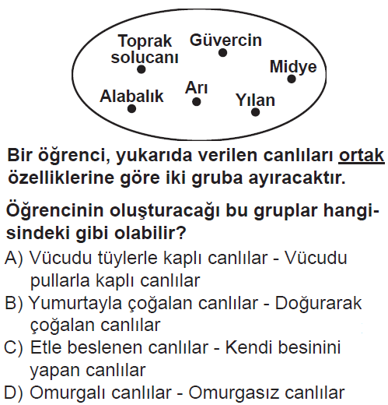

**49.** (2010 5. SINIF BURSLULUK)

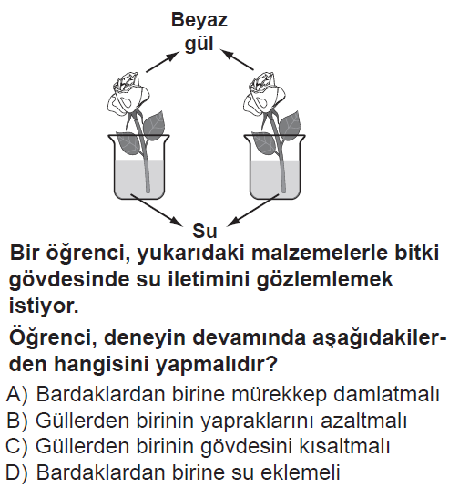

**50.** (2009 5. SINIF BURSLULUK)

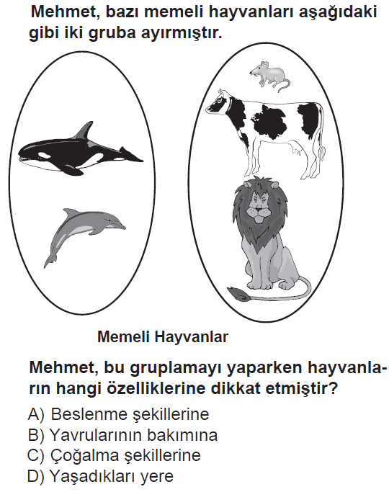

**51.** (2009 9.10.11 SINIFLAR BURSLULUK)

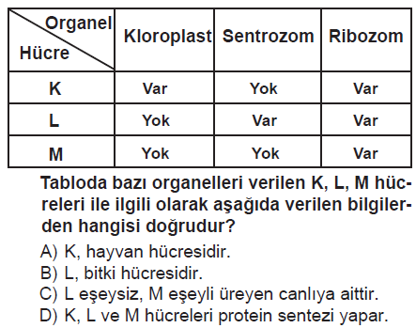

**52.** (2009 9.10.11 SINIFLAR BURSLULUK)

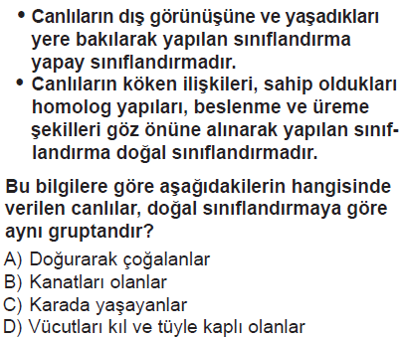

**53.** (2013 8.SINIF SBS)

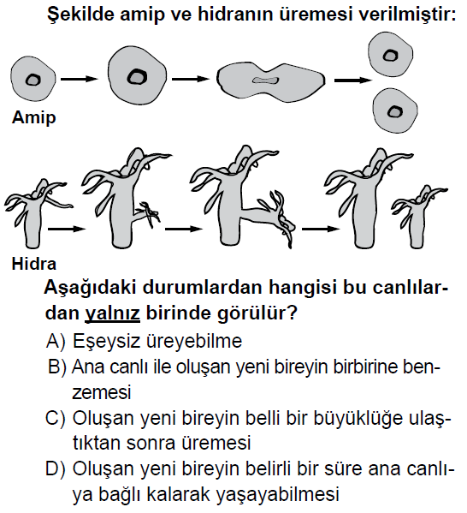

**54.** (2012 8.SINIF SBS)

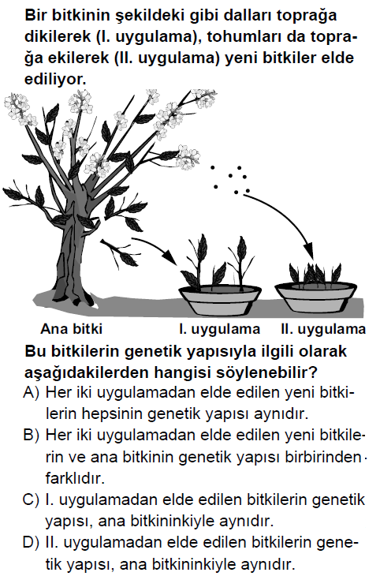

**55.** (2011 8.SINIF SBS)

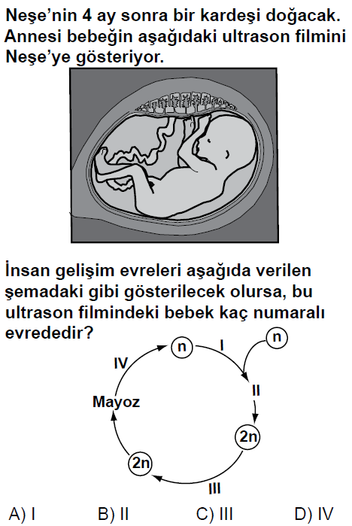

**56.**

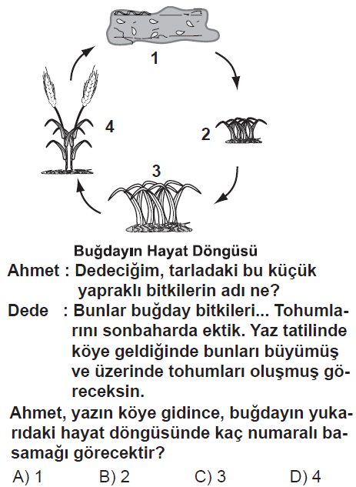

**57.** (2010 6.SINIF SBS)

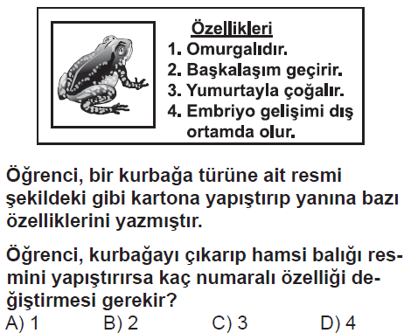

**58.** (2009 7.SINIF SBS)

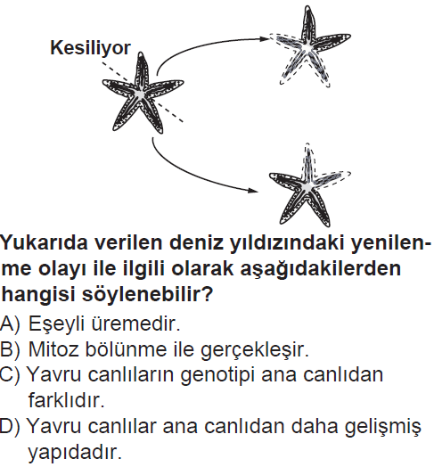

**59.** (2008 6.SINIF SBS)

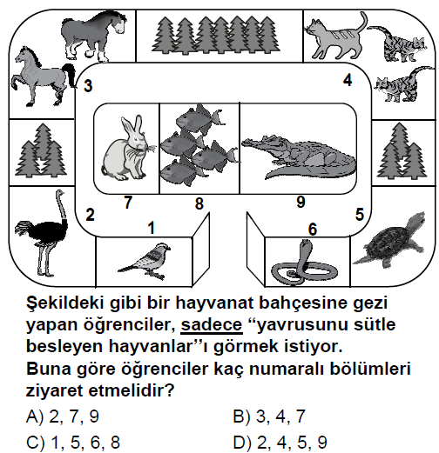

**60.** (2008 6.SINIF SBS)

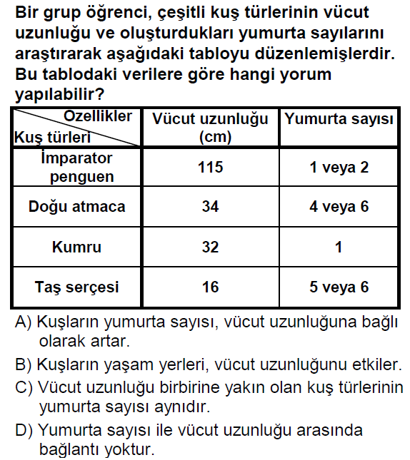

**61.** (2007 8.SINIF OKS)

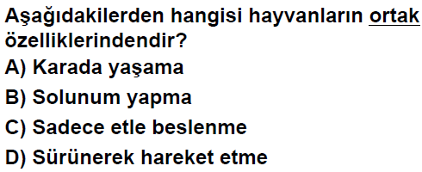

**62.**

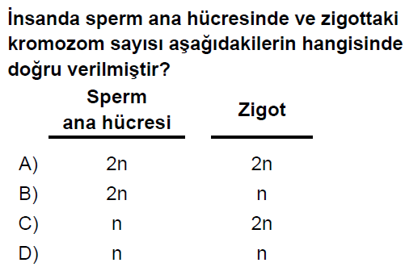

|  |  |  |  |
| --- | --- | --- | --- |
| ÜREME | | | |
| **6.Ünite** | | | |
| **1** | D | **41** | B |
| **2** | A | **42** | B |
| **3** | A | **43** | B |
| **4** | B | **44** | A |
| **5** | A | **45** | C |
| **6** | A | **46** | A |
| **7** | D | **47** | B |
| **8** | A | **48** | D |
| **9** | A | **49** | A |
| **10** | D | **50** | D |
| **11** | B | **51** | D |
| **12** | C | **52** | A |
| **13** | C | **53** | D |
| **14** | C | **54** | C |
| **15** | B | **55** | C |
| **16** | A | **56** | B |
| **17** | B | **57** | B |
| **18** | B | **58** | B |
| **19** | B | **59** | B |
| **20** | B | **60** | D |
| **21** | D | **61** | B |
| **22** | A | **62** | A |
| **23** | A |  |  |
| **24** | D |  |  |
| **25** | C |  |  |
| **26** | B |  |  |
| **27** | A |  |  |
| **28** | A |  |  |
| **29** | C |  |  |
| **30** | B |  |  |
| **31** | B |  |  |
| **32** | A |  |  |
| **33** | A |  |  |
| **34** | B |  |  |
| **35** | B |  |  |
| **36** | A |  |  |
| **37** | D |  |  |
| **38** | A |  |  |
| **39** | B |  |  |
| **40** | A |  |  |