### 7. SINIFLAR ÜNİTE ÜNİTE “ÇIKMIŞ SORULAR” 4. ÜNİTE: “SAF MADDE ve KARIŞIMLAR”

### 1. (2018 7. SINIF BURSLULUK)

### 

**2.** (2018 7. SINIF BURSLULUK)

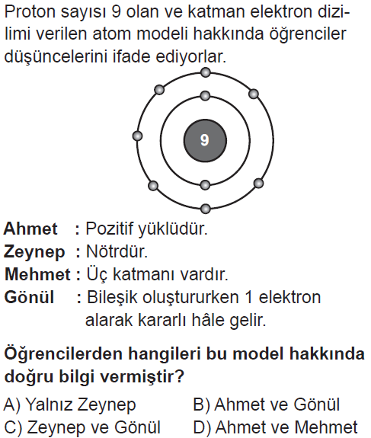

**3.** (2018 7. SINIF BURSLULUK)

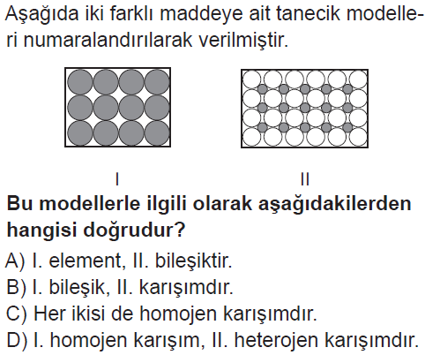

**4.** (2018 7. SINIF BURSLULUK)

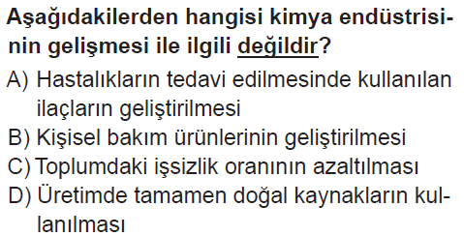

**5.** (2018 7. SINIF BURSLULUK)

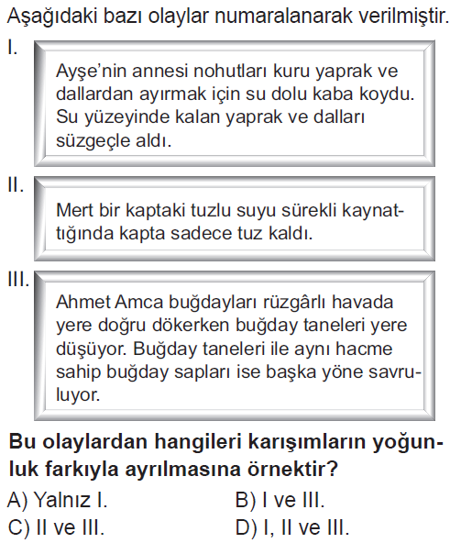

**6.** (2018 7. SINIF BURSLULUK)

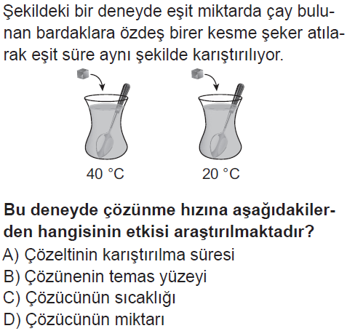

**7.** (2018 8. SINIF BURSLULUK)

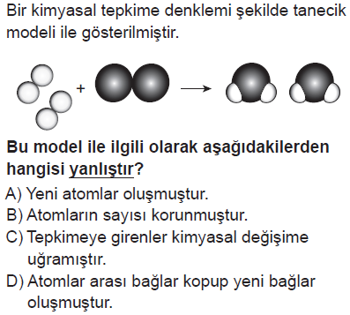

**8.** (2018 7. SINIF BURSLULUK)

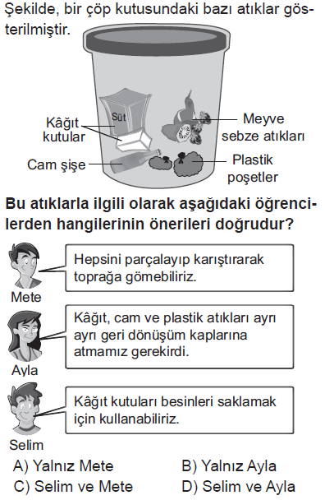

**9.** (2018 LGS)

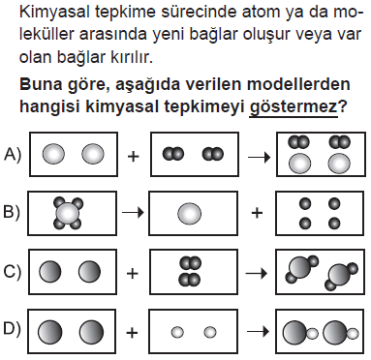

**10.** (2017 7. SINIF BURSLULUK)

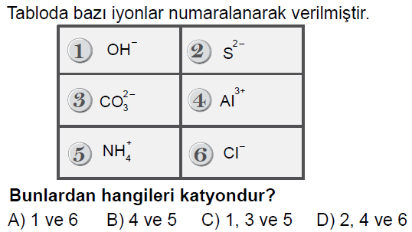

**11.** (2017 7. SINIF BURSLULUK)

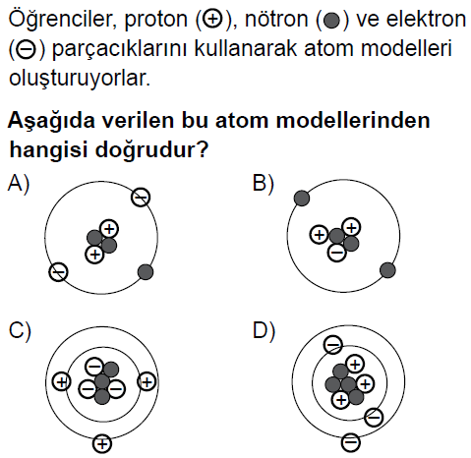

**12.** (2017 7. SINIF BURSLULUK)

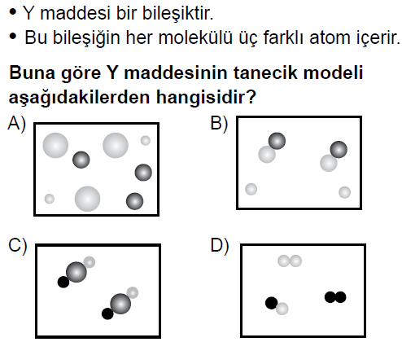

**13.** (2017 7. SINIF BURSLULUK)

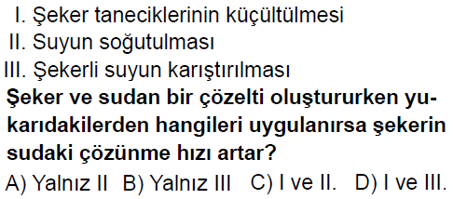

**14.** (2017 7. SINIF BURSLULUK)

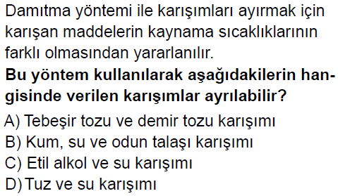

**15.** (2017 7. SINIF BURSLULUK)

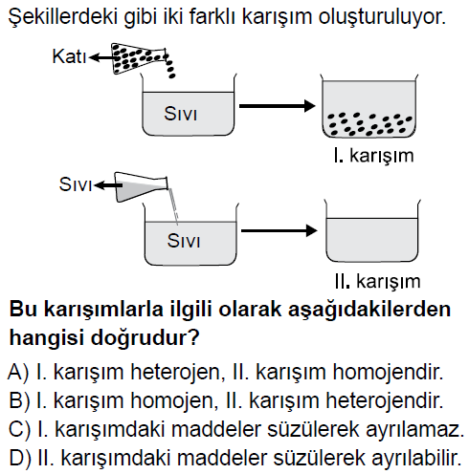

**16.** (2017 7. SINIF BURSLULUK)

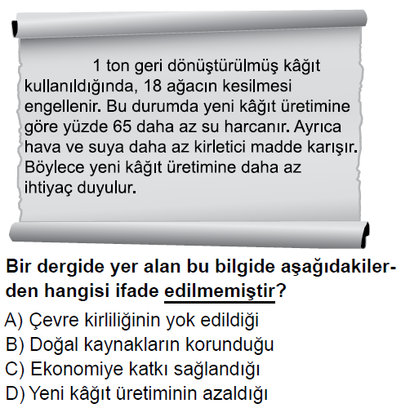

**17.** (2017 7. SINIF BURSLULUK)

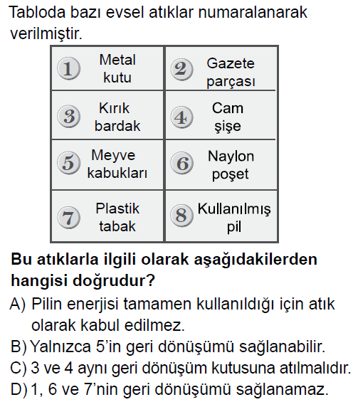

**18.** (2016 5. SINIF BURSLULUK)

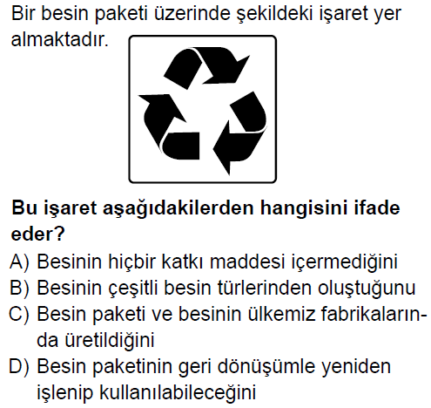

**19.** (2016 7. SINIF BURSLULUK)

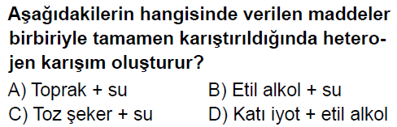

**20.** (2016 7. SINIF BURSLULUK)

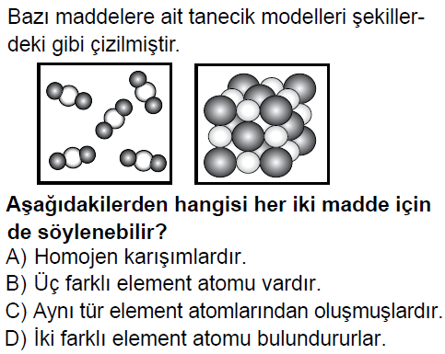

**21.** (2016 7. SINIF BURSLULUK)

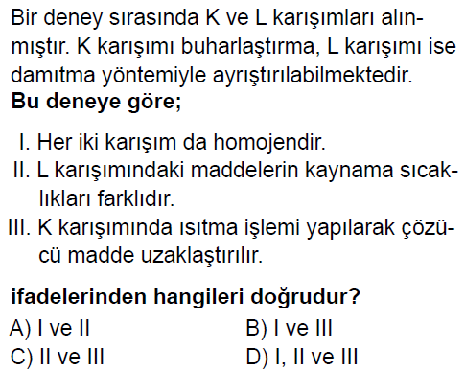

**22.** (2016 7. SINIF BURSLULUK)

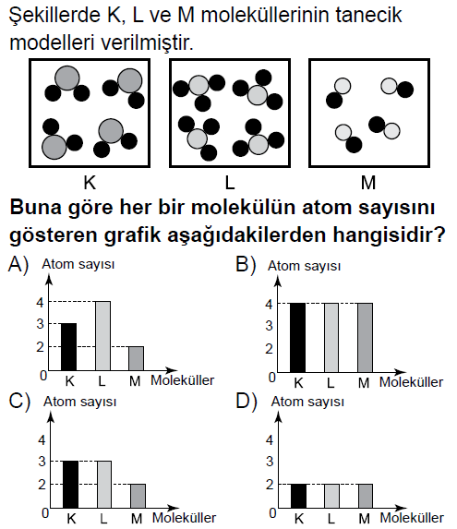

**23.** (2016 7. SINIF BURSLULUK)

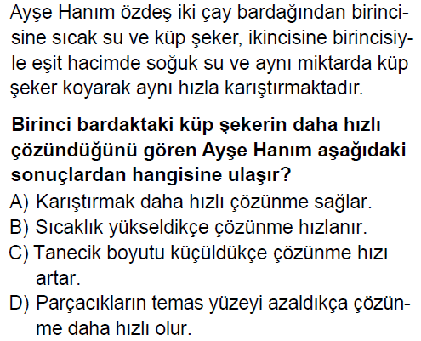

**24.** (2016 7. SINIF BURSLULUK)

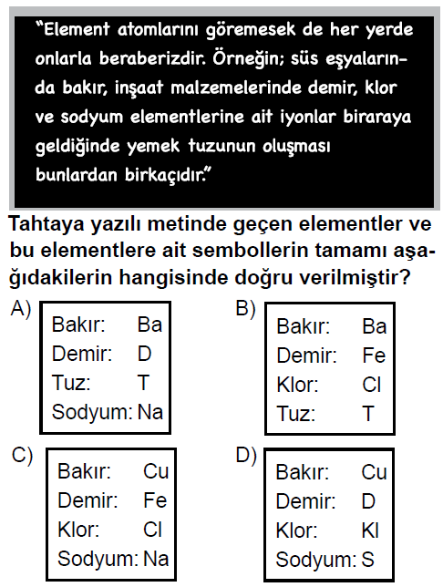

**25.** (2016 7. SINIF BURSLULUK)

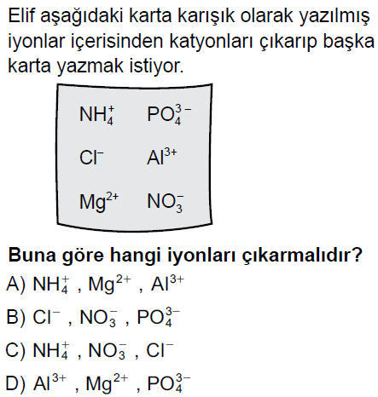

**26.** (2016 7. SINIF BURSLULUK)

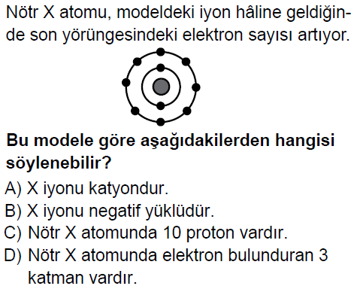

**27.** (2016 7. SINIF BURSLULUK)

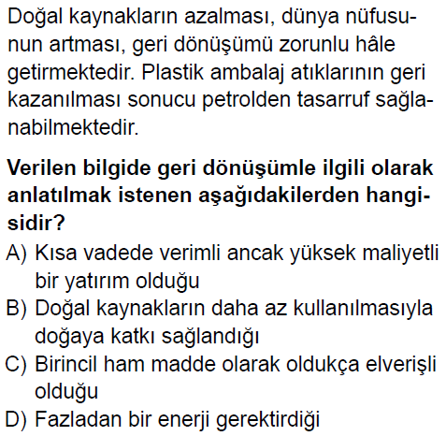

**28.** (2015 7. SINIF BURSLULUK)

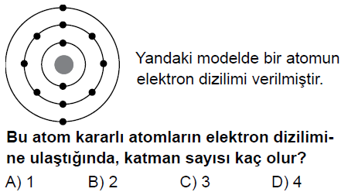

**29.** (2015 7. SINIF BURSLULUK)

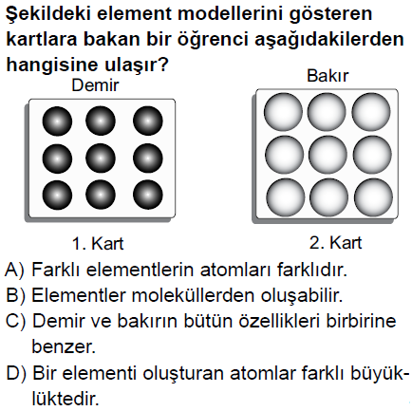

**30.** (2015 7. SINIF BURSLULUK)

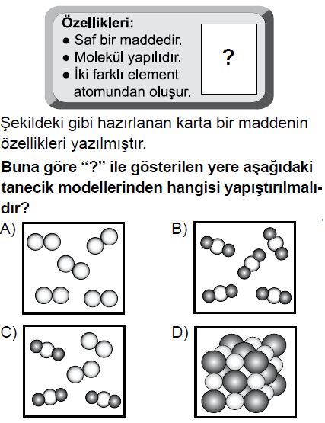

**31.** (2014 6. SINIF BURSLULUK)

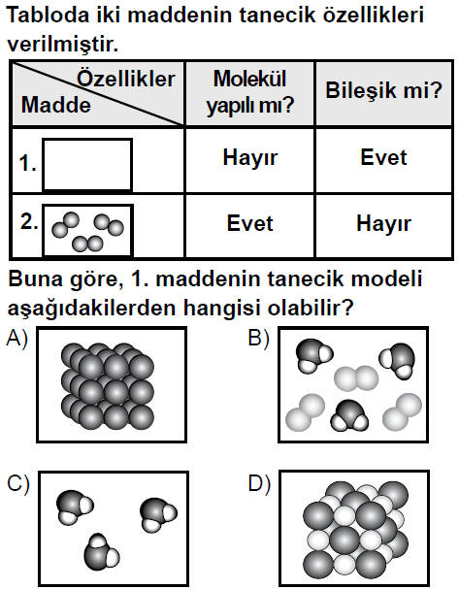

**32.** (2014 7. SINIF BURSLULUK)

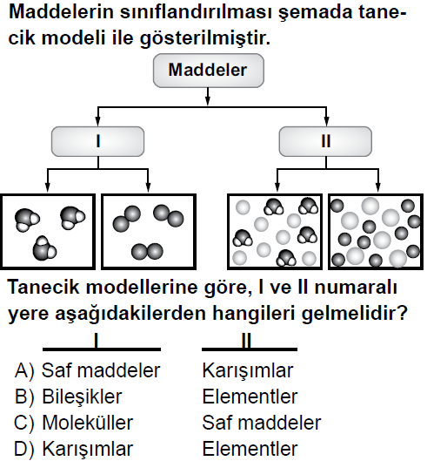

**33.** (2014 7. SINIF BURSLULUK)

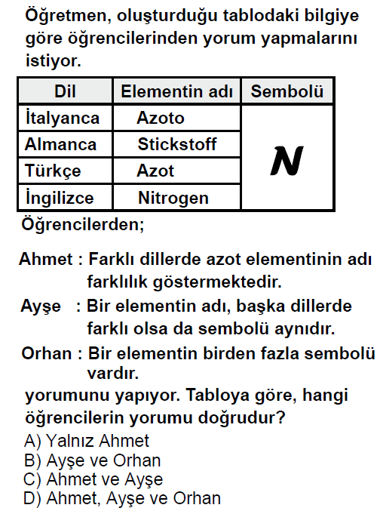

**34.** (2014 7. SINIF BURSLULUK)

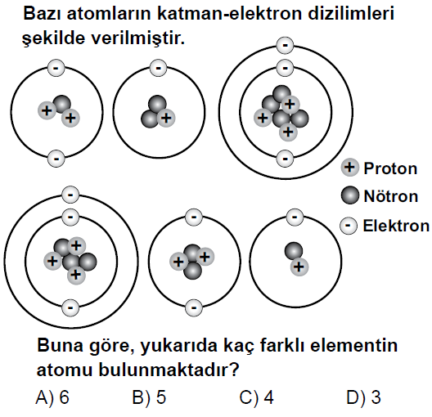

**35.** (2014 7. SINIF BURSLULUK)

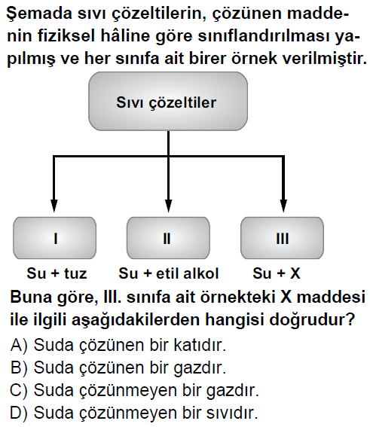

**36.** (2013 6. SINIF BURSLULUK)

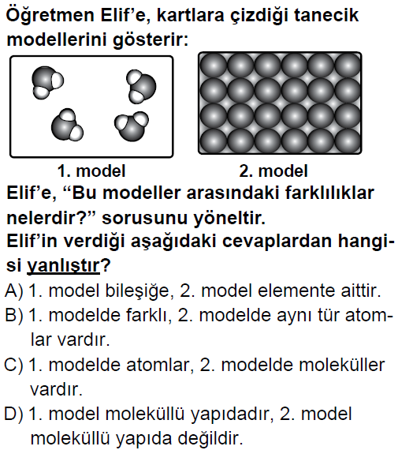

**37.** (2013 7. SINIF BURSLULUK)

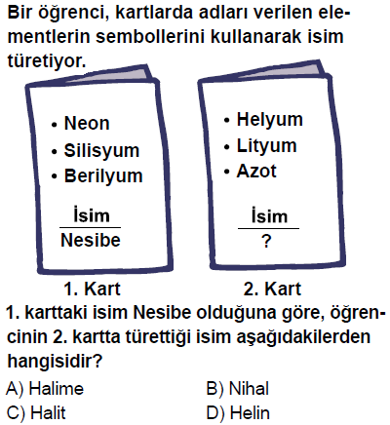

**38.** (2013 7. SINIF BURSLULUK)

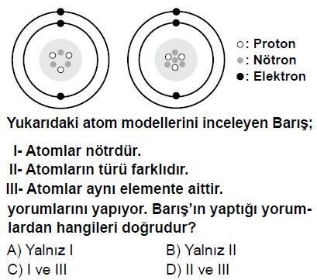

**39.** (2013 7. SINIF BURSLULUK)

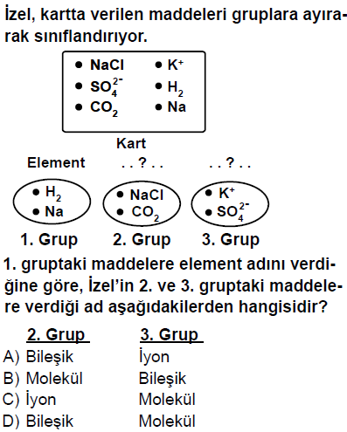

**40.** (2013 9. 10. 11. SINIFLAR BURSLULUK)

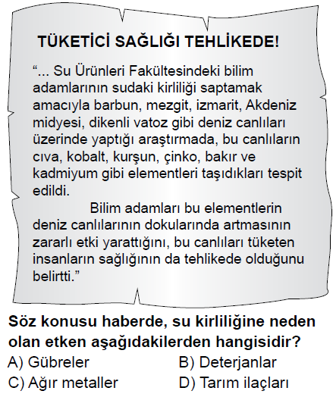

**41.** (2013 7. SINIF BURSLULUK)

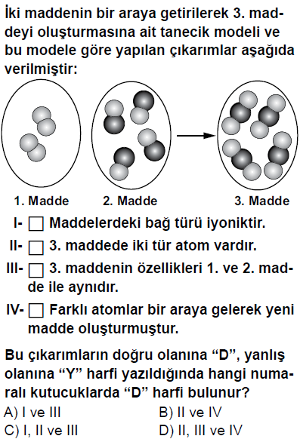

**42.**

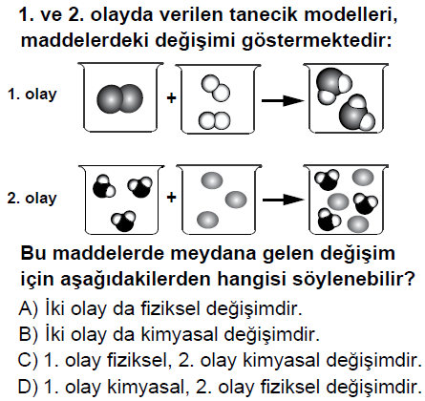

**43.** (2012 7. SINIF BURSLULUK)

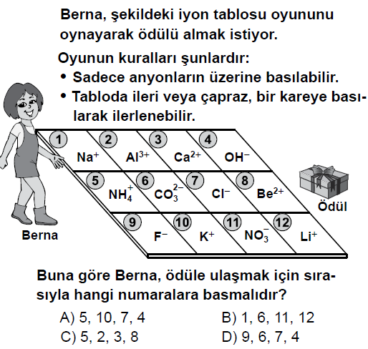

**44.** (2012 6. SINIF BURSLULUK)

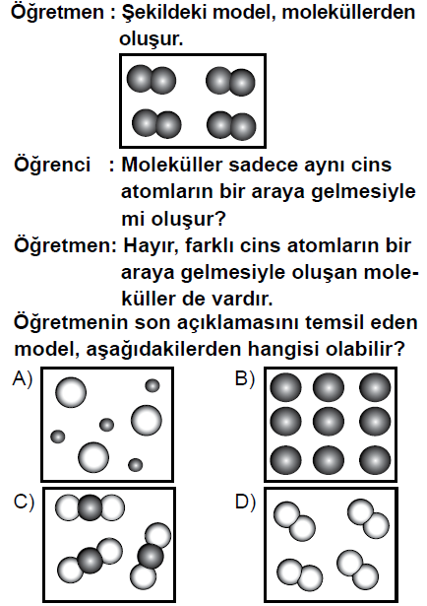

**45.** (2012 7. SINIF BURSLULUK)

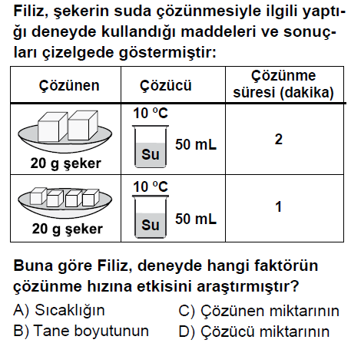

**46.** (2011 6. SINIF BURSLULUK)

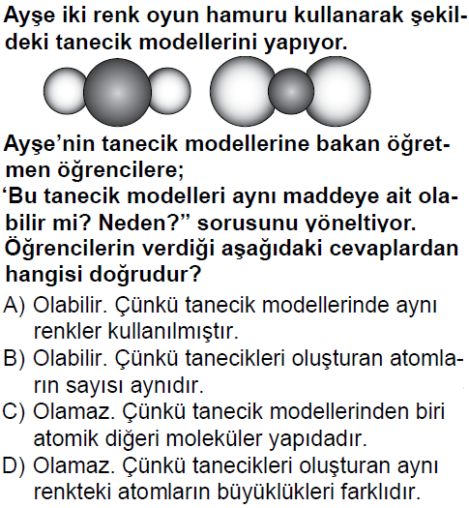

**47.** (2012 7. SINIF BURSLULUK)

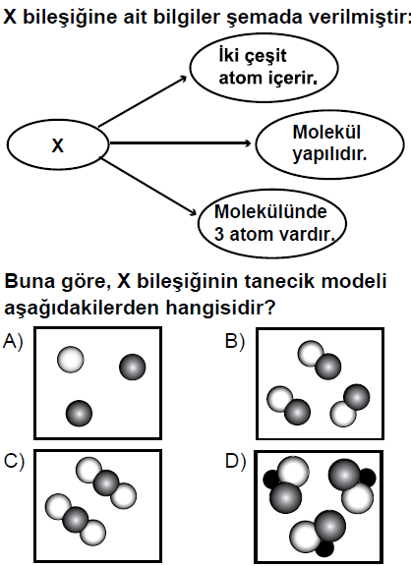

**48.** (2012 7. SINIF BURSLULUK)

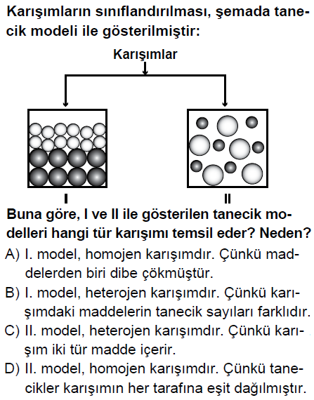

**49.** (2011 9.10.11 SINIFLAR BURSLULUK)

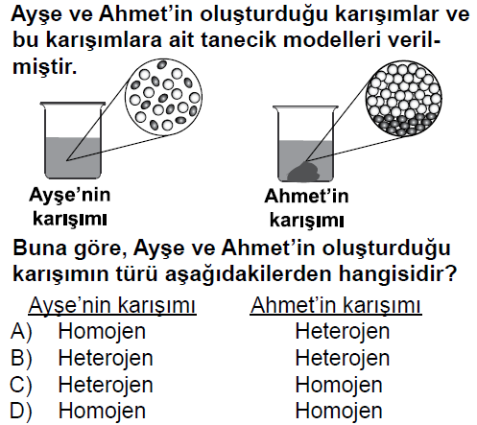

**50.** (2011 6. SINIF BURSLULUK)

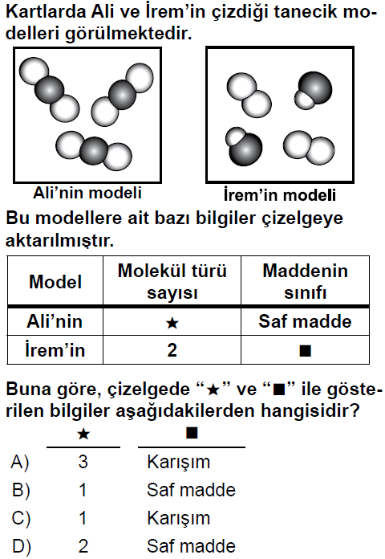

**51.** (2011 9.10.11 SINIFLAR BURSLULUK)

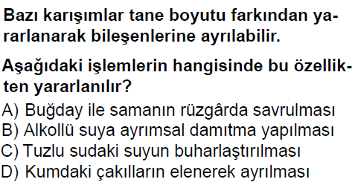

**52.** (2010 9.10.11 SINIFLAR BURSLULUK)

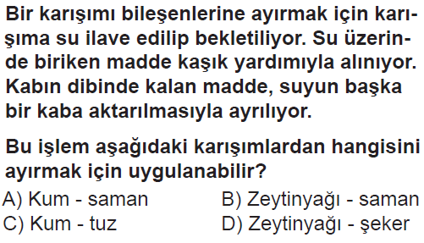

**53.** (2012 8. SINIF SBS)

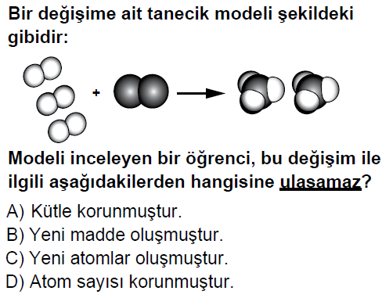

**54.** (2011 7. SINIF SBS)

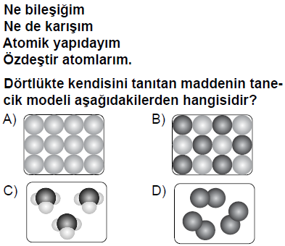

**55.** (2010 6. SINIF SBS)

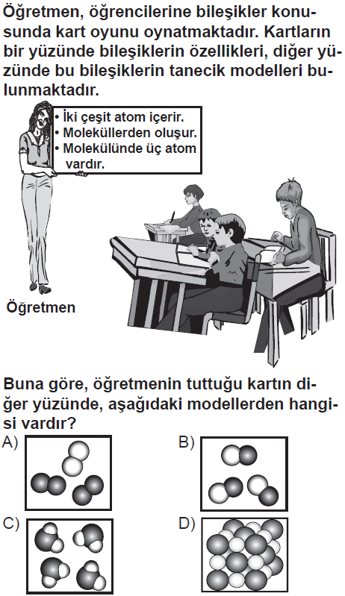

**56.** (2009 7. SINIF SBS)

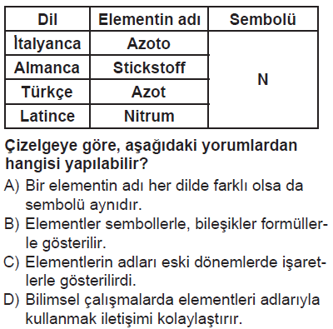

**57.** (2009 7. SINIF SBS)

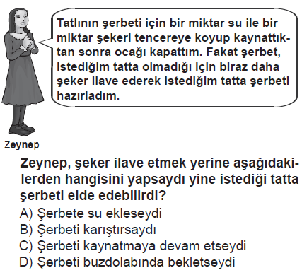

**58.** (2008 6. SINIF SBS)

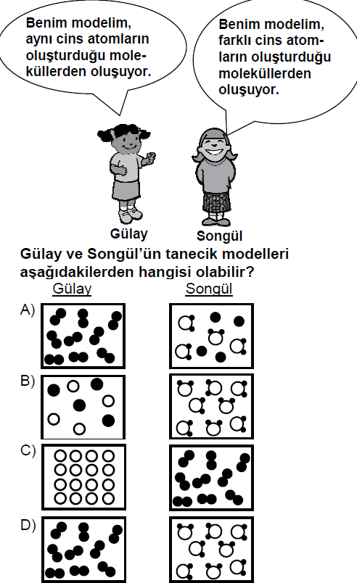

**59.** (2009 8. SINIF SBS)

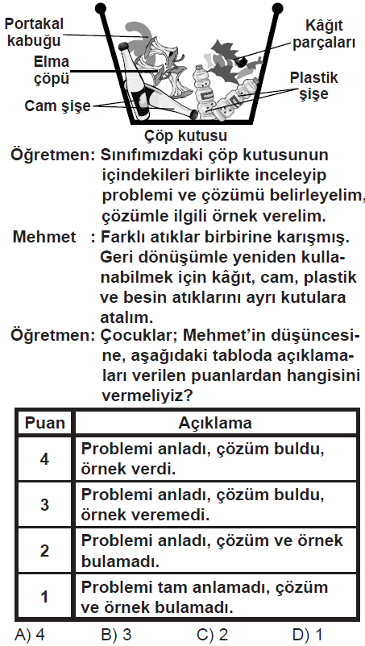

**60.** (2008 7. SINIF SBS)

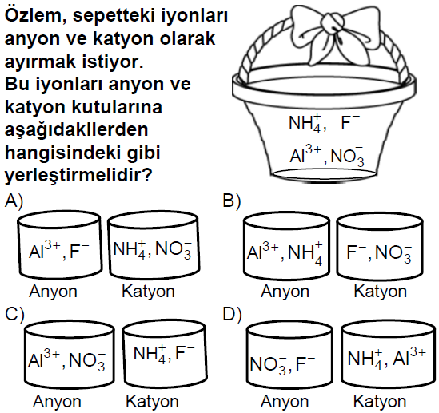

**61.** (2008 7. SINIF SBS)

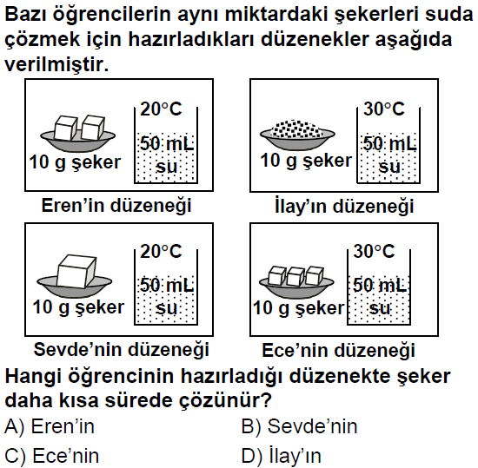

**62.** (2008 7. SINIF SBS)

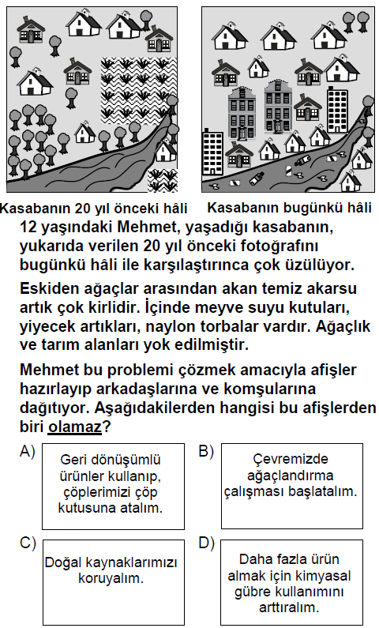

|  |  |  |  |
| --- | --- | --- | --- |
| SAF MADDE | | | |
| **4.Ünite** | | | |
| **1** | D | **41** | B |
| **2** | C | **42** | D |
| **3** | A | **43** | D |
| **4** | D | **44** | C |
| **5** | B | **45** | B |
| **6** | C | **46** | D |
| **7** | A | **47** | C |
| **8** | B | **48** | D |
| **9** | A | **49** | A |
| **10** | B | **50** | C |
| **11** | D | **51** | D |
| **12** | C | **52** | A |
| **13** | D | **53** | C |
| **14** | C | **54** | A |
| **15** | A | **55** | C |
| **16** | A | **56** | A |
| **17** | C | **57** | C |
| **18** | D | **58** | D |
| **19** | A | **59** | B |
| **20** | D | **60** | D |
| **21** | D | **61** | D |
| **22** | A | **62** | D |
| **23** | B |  |  |
| **24** | C |  |  |
| **25** | A |  |  |
| **26** | B |  |  |
| **27** | B |  |  |
| **28** | B |  |  |
| **29** | A |  |  |
| **30** | B |  |  |
| **31** | D |  |  |
| **32** | A |  |  |
| **33** | C |  |  |
| **34** | D |  |  |
| **35** | B |  |  |
| **36** | C |  |  |
| **37** | D |  |  |
| **38** | C |  |  |
| **39** | A |  |  |
| **40** | C |  |  |