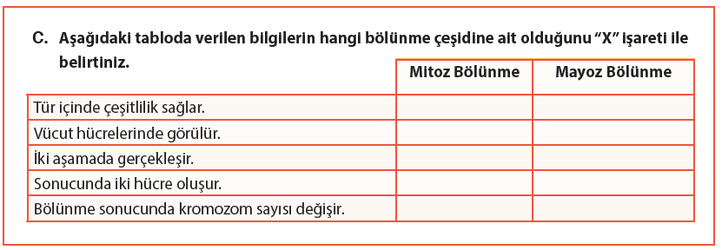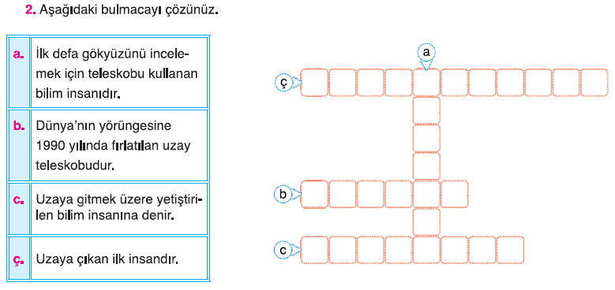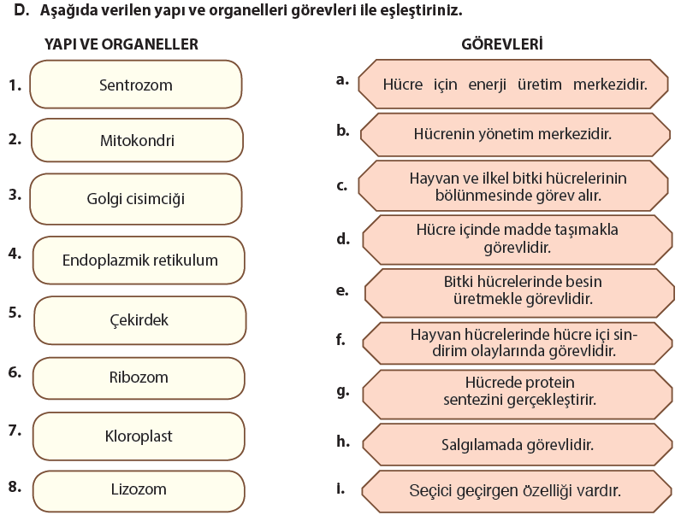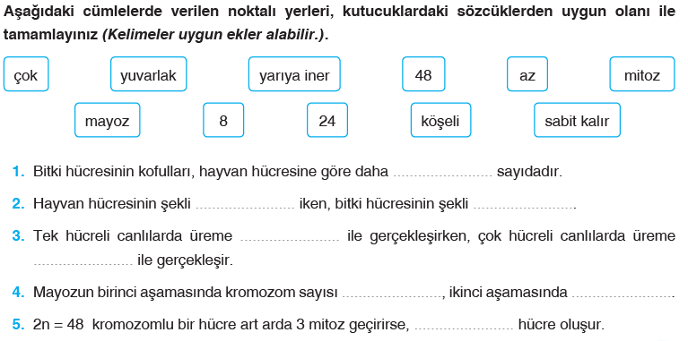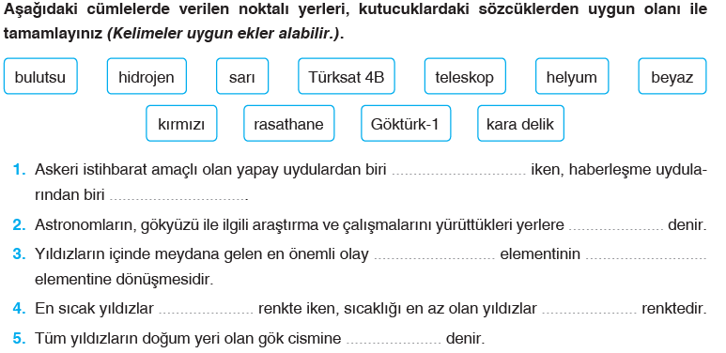

|  |  |  |  |  |  |  |  |
| --- | --- | --- | --- | --- | --- | --- | --- |
| 1 | 2 | 3 | 4 | 5 | 6 | 7 | 8 |
|  |  |  |  |  |  |  |  |

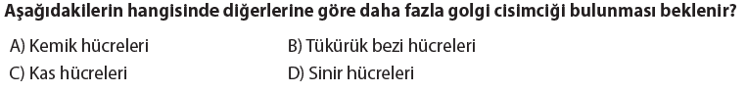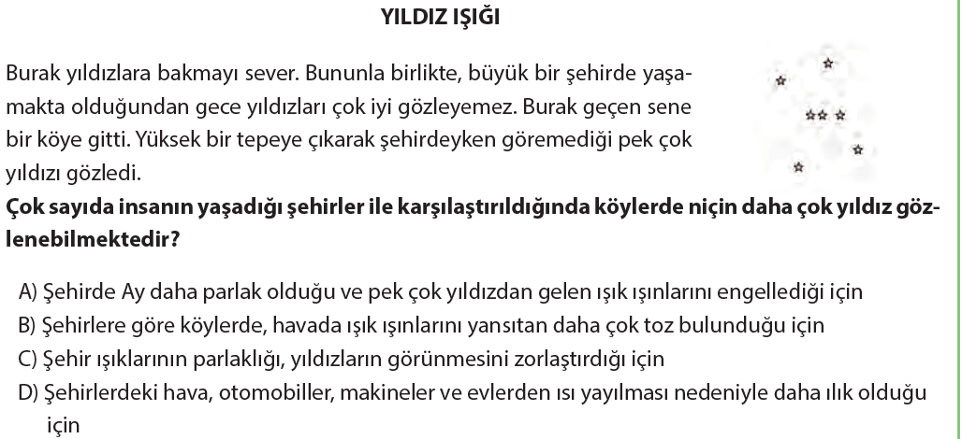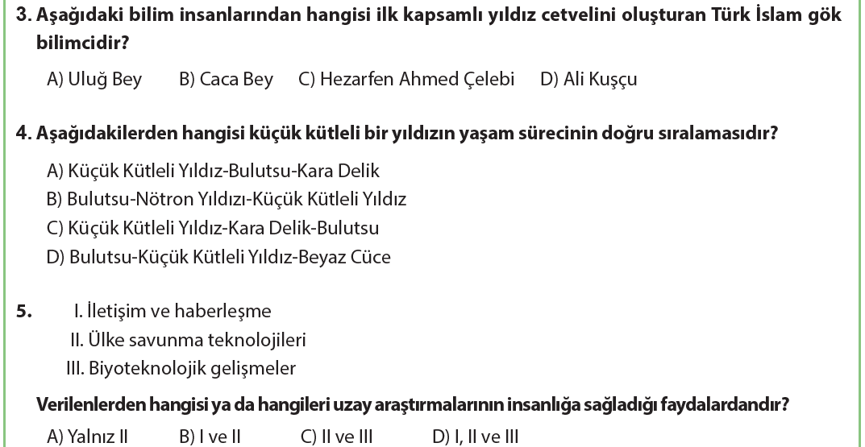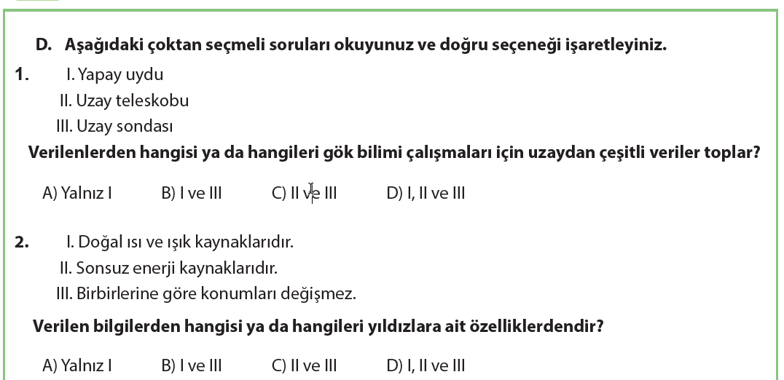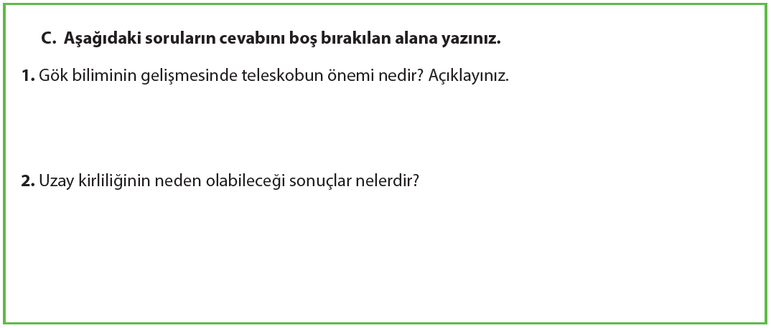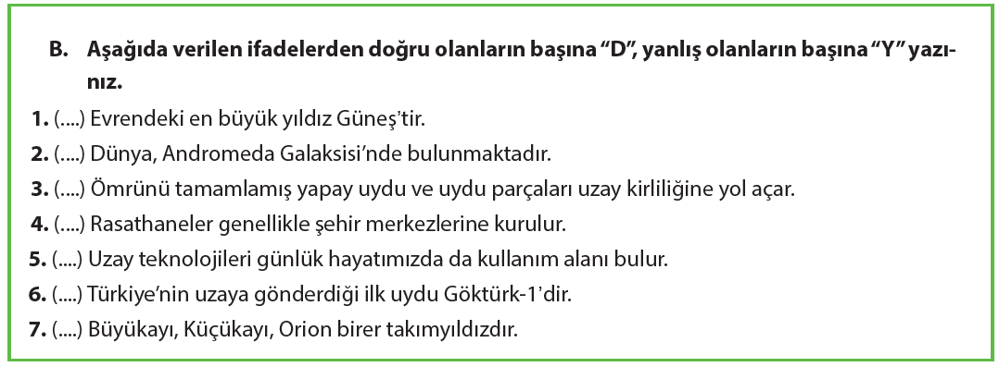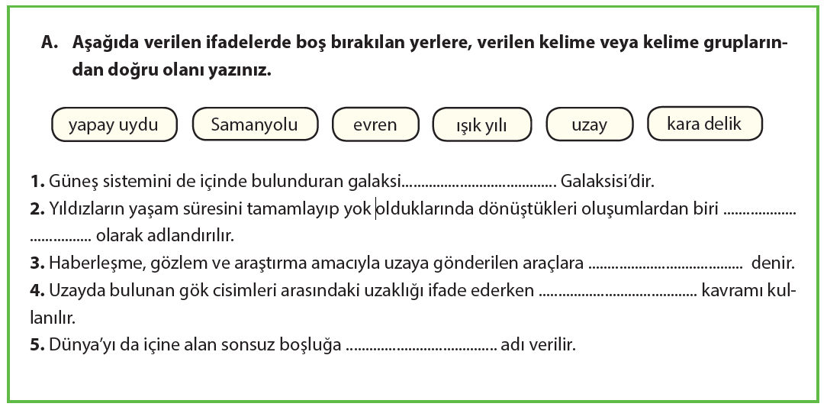

**…………………………. ORTAOKULU 2018/2019 7. SINIF FEN TEK. I. DÖNEM ORTAK I. SINAVI**

**ADI SOYADI: SINIFI: NO:**